APPLICATION OF LEARNING MODELS
COOPERATIVE TUTORS TO IMPROVE THE ABILITY OF MATHEMATICAL PROBLEMS
STUDENT CLASS VIII A SMP NEGERI 1 SUBANG AT MATERIAL
LINEAR EQUATION SYSTEM TWO VARIABLES

¹Imas Mulyasari, ²Elah Hayati, ³Warlim Setiawan, ⁴Riski Ananda
¹mulyasari569@gmail.com, ²elahhayati201@gmail.com , ³waysetiawan511@gmail.com , ⁴raputri.abriansyah@gmail.com
¹SMP Negeri 2 Subang, ²SMP Negeri 2 Jalan Cagak, ³SMP Negeri 1 Subang, ⁴IKIP Siliwangi Bandung

ABSTRACT

Mathematical problem solving ability of SMPN 1 Subang is still low. First, the average of mathematics learning result of grade VIII SMPN students 1 Subang still many who have not reached the value of KKM (KKM = 67) . Second, the lesson learned tends to use conventional learning model where the process happens more to the lecture and gives the exercise questions. Third, students tend to be passive, bored, not a few students chatting during the learning process. This study aims to improve the problem solving skills of mathematics students of class VIII SMP N 1 Subang by using cooperative learning model peer tutor. This research is a Classroom Action Research which passes threecycles with the subject of research is the students of class VIII A of the 2014 7 - 201 8 academic year with the number of students 34 people . Intruments of this research are tests on learning outcomes as a test of students' mathematical problem solving abilities of two- variable linear equation system for initial (before action) tests, cyclical I and II (after action) tests , and observation sheets for teachers and students to conditions of action implementation. The research procedure consists of: (1) planning, (2) implementation of action, (3) observation and evaluation, and (4) reflection. The average value of test results cycle II , ie 65.03 increased by 20.21 compared to the average value of the first cycle test result that is 44.82 . And the average value of h acyl test results of the third cycle is 82.26 increased by 17.23. The result of this research can be concluded that the mathematical problem solving ability of grade VIII A students ofSMPN 1 Subang can increase significantly after learning cooperative model of peer-assisted power point tutor.
Keywords : Mathematical Problem Solving, Peer Tutor, power point

- PRELIMINARY
Problem solving as one aspect of high-level thinking ability. Polya states that problem solving is a very high level of intellectual activity. Problem solving is an intellectual activity to solve problems encountered by using the stock of knowledge already possessed. This opinion is supported by Branca's statement (Sumarmo, 1994: 8) that problem-solving abilities are common goals in mathematics courses, even as the heart of mathematics, meaning that problem-solving skills are basic skills in a math course. Problem solving is important in the purpose of mathematics education because in everyday life people can never escape from problems .
But the reality shows that students' mathematical problem solving ability is less encouraging. Student achievement in mathematics is generally still low. (Sumarmo, 1993) reported that the problem solving ability of high school students was not satisfactory. This situation is reflected also from the results of the National Examination (UN), there are still many students fail in mathematics. In addition, in mathematics competitions such as mathematics olympiad, the problem-solving problem of mathematical problem solving is generally not successfully answered students correctly.
One effort to improve the learning process is by choosing the appropriate and innovative learning model in mathematics learning. One of the learning models that can be applied in order to improve problem solving ability is through cooperative learning model of peer-assisted tutor power point. The advantage of learning to use power point among others the first to improve students' digestibility of information or mathematics learning, both as an interesting communication medium so that participants feel not bored with the math learning atmosphere. Manfaaat learning with peer tutors such asfacilitate students to express opinions or thoughts and difficulties to his own friends.

- PROBLEM SOLVING SKILL
The ability to solve mathematical problems is an action to solve a problem or process that uses the power and benefits of mathematics within solving problems, is also a method of finding solutions through troubleshooting steps. Can also be said that solving the problem as an attempt to find a way out of a difficulty.
Mathematical problem solving indicators are as follows:
1. Understand the problem
2. Plan a settlement strategy
3. Running the settlement plan
4. Check the truth value .
- KOOPERATIVE LEARNING MODEL TUTOR SEBAYA
Cooperative learning model is a learning model that puts students together in groups with different levels of ability or gender or background . In addition, before cooperative learning is implemented, students should be allowed cooperative skills to be used in later learning groups. Cooperative skills that among others, among others, respect the opinions of others, encourage participation, courage to ask, encourage friends to ask, share the task, the basic elements of cooperative learning as follows:
- Students in groups should assume that they live together
- Students have a sense of responsibility for everything in their group to be their own
Advantages of cooperative learning models tutor sebay a

- RESEARCH METHODS
In this study classroom action research is used. This study was conducted from November 8 , 2017 to 2 November 2 , 2017 in the odd semester of the academic year 2017-2018 in SMPN 1 Subangwith the subject of research is the students of class VIII A with the number of students as much as 3 4 people consisting of 14 men and 20 people women.
The instrument used is a test of learning outcomes as a test of students' mathematical problem solving abilities of a two-variable linear equation system , for preliminary (before action) tests, cycles I and II (after giving of action); and observation sheets for teachers and students for the conditions of action implementation.
Sources of data are research personnel consisting of teachers and students, the type of data that is quantitative data and qualitative data obtained through t es the results of study and observation. Andthe data collecting are: (1) Data about learning condition of Linear Equation System Two Variables with cooperative learning model supported by powerpoint taken using observation sheet covering observation to teacher and student; (2) Data on learning achievement was taken by using test included cycle I, cycle II test and cycle III test, and n; (3).
Data obtained from this research that comes from the test cycle I, the test cycle II and test cycle III . All data is processed by using microsoft excel by calculating the average and see the average comparison of each cycle.

- RESEARCH RESULT

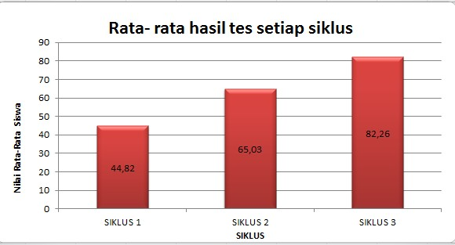

Figure 1.2 Average value of tests per cycle
From the picture above diagram shows that:
- The results of research cycle I is the average value of the results of the test cycle I is equal to 44 , 82 .
- The results of the research cycle II is the average value of the test results cycle II yai tu of 65 , 03 and t is an increase of 20.21 from cycle I of 44.82 .
- The results of the third cycle study is the average value of the results te s third cycle is equal to 82, 26 and t erjadi increase of 17.23 from the first cycle I is 65.03.
- Results of Cycle I Research
  - Planning ( Plan )
Things are done at this stage is properly accounting RPP atan first cycle consisted of one meeting on the matter "Systems of Linear Equations Two Variables" d ith the use of cooperative learning model powerpoint-assisted peer tutors.
  - Implementation of Action ( Do )
The implementation of the action was carried out by the researcher, math teacher to welding VIII A SMP Negeri 1 Subang, while acting as observer (observer) were two teachers from other schools . . The first cycle of learning is carried out in a single meeting.
The presentation of the first class is held on Wednesday 8 November 2017 with the material "SPLDV substitution method ". The pre- prepared RPP uses cooperative learning model with powerpoint help . .
  - Evaluation ( See )
E valuation with the test cycle I on Wednesday, November 8 , 2017. This activity was conducted to find out how far the solution of mathematical problems of students on the material " System of Two Variable Linear Equations " after learning with peer tutors with the help of powerpoint .
- Cycle Research Result II
    - Planning ( Plan )
T AHAP this is the manufacture of RPP based on the syllabus y ang referenced research indicator: (1 ) complete SPLDV with combined method (elimination and substitution).
Then the researchers made the observation sheet addressed to teachers and students and designed the evaluation tools to test the first cycle I.
    - Implementation of Action ( Do )
Implementation of the action is done by teacher of math class VIII A SMPN 1 Subang . Action learning cycle I first implemented in one meeting.
Second cycle meeting k edua held on Thursday , November 9 , 2017 with the material " SPLDV ". Pre-prepared RPPs using cooperative peer-assisted peer-assisted tutor models .
    - Evaluation ( See )
T es cycle II on Thursday, November 9, 2017. The average I cycle test score I is 65 , 93 . This shows that the average score of students' mathematical problem solving ability there was an increase of 20 , 21 from siklu s I

- Results Cycle I I
- Planning ( Plan )
The things that are done at this stage are the making RPP made for cycle III consists of 1 meeting indicator: (1) m arouses a mathematical model of word problems. (2) m enyelesaikan mathematical models of the problems associated with SPLDV
Then the researcher made the teacher and student observation sheet , and designed the evaluation tool for the cycle III test.

- Implementation of Action ( Do )
The action of learning cycle II I was conducted in one meeting. P is Wednesday , the 15th November 2017 with material " SPLDV ". Pre-prepared RPP uses cooperative peer-assisted tutor peer model.
- Evaluation ( See )
E valuation with the name of the third cycle test conducted on Wednesday, November 15, 2017 . The average test value of cycle II I is 82 , 26 . This result shows the mathematical problem solving ability of students of class VIII A SMPN 1 Subang to the material there is already increase again of 17,23 from cycle I I equal to 65,03 .

F. DISCUSSION
Cycle 1
Based on the learning steps in the cycle RPP I. Implementation of cooperative learning model powerpoint-assisted peer tutors. in the first cycle is done by lecture, question-answer, and discussion methods and has indicators: (1) Complete SPLDV by using substitution method .
The average value of the test cycle I is 44 , 82 . This shows that the average value of mathematical problem solving ability of grade VIII A students of SMPN 1 Subang to the material is still low. It aims to know the learning outcomes with peer-assisted peer-assisted tutors for each meeting conducted.
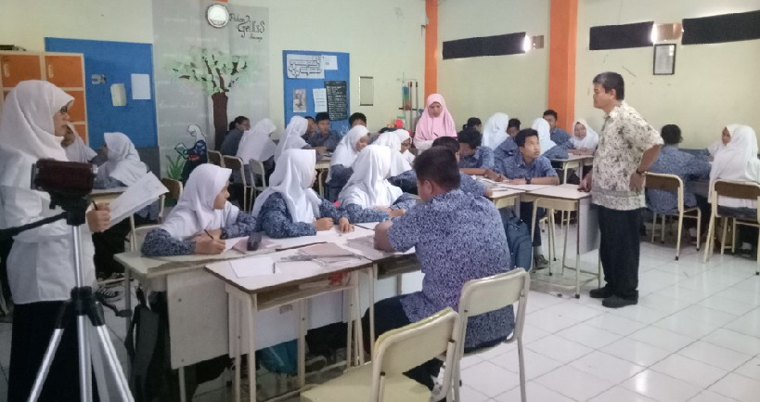

Cycle II
Based on the results of observation and evaluation on the action of cycle I, the researchers together with the teacher plan the action cycle II, so that the weaknesses that occur in the implementation of the action cycle I can be improved . Things that must be improved by the teacher on the implementation of the second cycle of action are as follows: ( 1 ) The number of supplied LKs is subtracted from the number of Cycle KL I ; (2 ) Number of groups from 6 groups to 8 groups (members of each group of 4-5 people ) .
The test results indicate that the students have been able to demonstrate their mathematical problem solving ability. The results of this test also shows students' mastery of the classical subject matter and still must be given further action. So there needs to be additional action so that they really understand the material " SPLDV " this.
At the end of the learning cycle II, teachers together with students summarize the results of discussion and reflection. Observation sheets for teachers and students are still used by researchers to observe the learning process that lasts from start to finish.

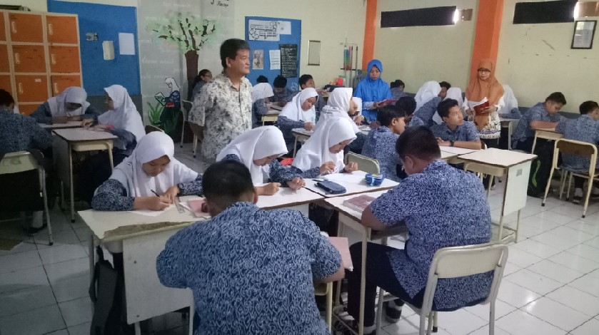

Cycle III
Based on the results of observation and evaluation on the action cycle II, the researchers along with the teacher plan action cycle III, so that the weaknesses that occur in the implementation of action cycle II can be improved and achieve maximum results. The things that teachers need to improve on the implementation of action cycle III are as follows: (1) The teacher must be able to organize the time well as planned in the learning scenario; (2) Teachers should give the students an opportunity to express their initial ideas about examples that are core learning media. This is to foster the spirit of students in understanding and planning the solution of the problem even though basically the teacher must tell and explain the right way .

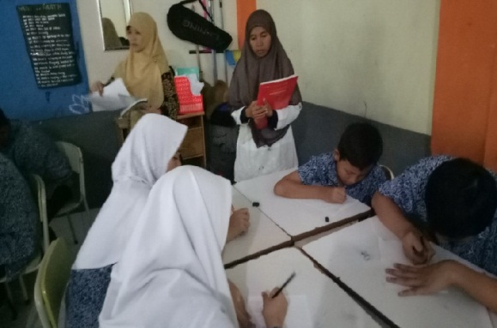
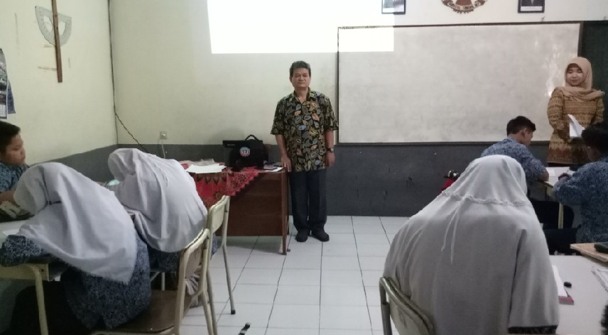

- CONCLUSION
Based on the results of the analysis and discussion, it can be concluded that the mathematical problem solving ability of students of class VIII A SMPN 1 Subang on the material Linear Equation System Two Variables can be improved through coopearective learning model peer-assisted tutor power point.

- BIBLIOGRAPHY

Effendi, S. (2012). Survey Research Methods. Jakarta: LP3ES.
Ormrod, JE (2009). Educational Psychology: Helping Students Grow and Grow. Jakarta: Erland.
Polya, G. (1973). How to Solve It: A New Aspect of Mathematical Method (2 ^{nd} Ed). Princeton New Jersey: Princeton University Press.
Ruseffendi, ET (1991). Introduction to Helping Teachers Develop Their Competencies in Mathematics Teaching to Improve CBSA. Bandung: Tarsito
Sukamti, (2008). Improving Student Learning Outcomes in Completing SPLDV Material Problems through Cooperative Learning Implementation Peer Tutor for Students VIII D SMPN 5 Sragen Semester 1
Sumarmo. U. (1993). Role of Logical Ability and Learning Activity on Mathematical Problem Solving Ability at High School Students in Kodya Bandung. Report of IKIP Research Result Bandung: unpublished.

