EMPOWERMENT OF CORAL CADETS IN TOURISM MANAGEMENT IN WARNASARI VILLAGE, PANGALENGAN DISTRICT, BANDUNG REGENCY
Umi Hani¹, Ika Sri Hastuti², Erti Dinihayati³
Departement of Social Work Universitas Pasundan
International Relations
Business Administration
Abstract
Karang Taruna is a form of youth organization that can be a forum for youth to express ideas, ideas, creativity that are useful for individuals and society. In Warnasari village, Karang Taruna is actively involved in all community activities because Karang Taruna as a youth organization is considered capable of bringing change to improve the welfare of its citizens and the surrounding community. The participation of Karang Taruna in the management of tourist attractions in the Warnasari village which has a lot of natural tourism potential and can improve the village economy, one of which is the natural tourist attraction of Situ Cileunca which has many rides that can be enjoyed by tourists. So far, tourist attractions are managed by investors professionally, but Karang Taruna is involved in technical management. One of the problems faced is the low competence of youth and tends to become unemployed in the village. Real conditions in various regions show that many youths are out of work and unable to create jobs, the cause being the low level of education and skills. This study aims to determine the extent of empowerment in seeing the potential of Karang Taruna in advancing tourism and its impact on improving the community's economy. Barriers and challenges of Karang Taruna in tourism management. The method used in this research is descriptive qualitative with data collection through in-depth interviews, observation, and documentation studies. The results show that the ability of youth organizations in tourism management is still weak, especially their management capabilities, management is still mostly carried out by investors, youth organizations are only involved in managing infrastructure. The obstacles faced by Karang Taruna in participating in managing tourist attractions are weak knowledge in management management, weaknesses in mastering technology, and foreign languages ​​because many foreign tourists are starting to come. The challenge is that Karang Taruna is required to master everything as well as possible, because the management of tourism in Warnasari Village is not possible forever by investors and the surrounding community only gets some of the benefits because many things that cannot be denied are hampering progress in tourism, causing economic progress to be hampered. .
Keywords: Youth Organization, Youth Empowerment, Tourism

- Introduction
Karang Taruna is a non-partisan youth organization that developed in Indonesia which grew on the basis of awareness and to this day still exists in every village/kelurahan area which is primarily engaged in social welfare. Karang Taruna is one of the pillars of the nation that has the potential to continue to be developed in order to build the nation and state. As one of the nation's potentials that develops and is taken into account, it is natural for Karang Taruna to be able to show its identity as an organization that is able to bring change to improve the welfare of itself and the surrounding community. As a forum for developing the potential of the youth generation, Karang Taruna is regulated in the Regulation of the Minister of Social Affairs of the Republic of Indonesia No. 77/HUK/2010 concerning the Basic Guidelines for Youth Organizations which states that Karang Taruna is a social organization as a forum and means of development for every member of the community that grows and develops on the basis of awareness and social responsibility from, by and for the community, especially the younger generation in the region. Its movement in the field of Social Welfare Enterprises means that all program efforts and activities organized by Karang Taruna are aimed at realizing the social welfare of the community, especially the younger generation.
Karang Taruna is a place for the younger generation (youth) to organize from an early age so that various kinds of ideas and creativity can be channeled that become the provision of life skills. The main task and function of Karang Taruna is as a vehicle for the development of the younger generation (including youth empowerment). Based on this, the existence of Karang Taruna as a social organization for the development of the younger generation has a strategic position and is needed in answering social problems, one of which is the problem of unemployment.
Karang Taruna as a forum for empowering the younger generation has a strategic position and is increasingly needed in responding to the problems of unemployment and poverty. Karang Taruna is a community social organization as a forum and means of developing each member who has the main task together with the Government to organize the development of the younger generation and social welfare.
The Karang Taruna Village of Warnasari Village has a strategic role in the development of social welfare because the existence of Karang Taruna which is located in almost all villages/kelurahan is in direct contact with people with social welfare problems as well as other potential and sources of social welfare. The government realizes that without the participation of the community, it is impossible for social problems to be handled, for that it is hoped that the participation of all potentials and sources of social welfare, including Youth Organizations.
Warnasari Village is located in Pangalengan District, Bandung Regency, which is already famous as the largest producer of cow's milk in the Greater Bandung area. In addition, the Warnasari Village area is also known for its soil fertility so that it becomes one of the vegetable-producing areas that meet the need for vegetables in the Greater Bandung area, and also in this area there is one tourist location that is well known by the public, namely the Situ Cileunca area. and tea plantations. Situ Cileunca is 45 km south of Bandung City. Situ Cileunca is a hydropower/reservoir for power generation located at an altitude of 1550 DPL. Situ Cileunca has an area of ​​181 Ha and a water volume of 11,500,000 m with an average depth of 6.4 m. The water that fills the lake comes from the Palayangan river. The site is surrounded by two Malabar tea plantations managed by PTPN VIII. According to history, Situ Cileunca is the private area of ​​a Dutch citizen named Kuhlan who used to live in Pangalengan. The construction of Situ Cileunca was carried out for a long time, namely for 7 years (1919 - 1926) by damming the flow of the Cileunca river, so that a lake was made which eventually became a dam which is now named Pulo Dam.
The development of the Situ Cileunca tourist area is an example of the rapid progress of the tourism sector in Warnasari Village, Pangalengan District, Bandung Regency, this is evidenced by the many natural tourism places that are managed professionally and the arrival of investors interested in managing natural tourism in Warnasari Village. But even though the management is professionally carried out by investors, Karang Taruna is involved in tourism management such as in managing rides at tourist attractions, or looking for natural tourism potential in the Warnasari area. The involvement of Karang Taruna in tourism management is part of empowerment so that it is hoped that Karang Taruna has a concern for the area, has a desire to learn new things such as how to manage tourist attractions, what are the needs in managing tourist attractions, tourism that can be developed in the village. Warnasari uses the rich natural potential so that it can be explored to improve the welfare of rural communities without disturbing nature. In fact, Karang Taruna understands the Warnasari Village area better for exploring new tourism potential, and this is then offered to investors to be managed and developed. The involvement of Karang Taruna in tourism management as a form of empowerment means providing resources, opportunities, knowledge and skills to residents to improve their ability to determine their own future and participate in and influence the lives of their people (Jim Ife, 1995: 182).
The concept of empowerment according to Payne (1997) in Isbandi (2002:162) suggests that an empowerment (empowerment), the power to make decisions and determine the actions that he will take is essentially aimed at: "Helping clients gain power and determine the actions they will take related to themselves, including reducing the effects of personal and social barriers to action. This is done through increasing the ability and self-confidence to use the power he has, among others through the transfer of power from his environment”.
The above concept is in accordance with the principles in Welfare Science which essentially is to encourage clients to determine for themselves what to do in an effort to overcome the problems they face, so that clients have full awareness and power in determining what is best in their lives, because in the process of empowerment CROSS-FIELD EMPOWERMENT
Empowerment is an effort in the development of social welfare, which is distinguished from the development goals that are worked on, but the ultimate goal is for the welfare of the community (Isbandi, 2002: 163). Empowerment may vary based on the development objectives. As shown in the scheme below, various kinds of empowerment can be combined and complement each other in order to create community welfare. Empowerment in one field will certainly be interrelated and cannot be separated, for example, economic empowerment must also pay attention to environmental empowerment so that there is no all-out exploitation of existing resources, or when we talk about economic empowerment, for example in the tourism sector, it certainly cannot be separated from spiritual and social empowerment. One example of empowerment efforts that try to synergize between economic, environmental, social and spiritual empowerment is in the management of tourism in Warnasari Village, Pangalengan District, Bandung Regency by involving Karang Taruna.

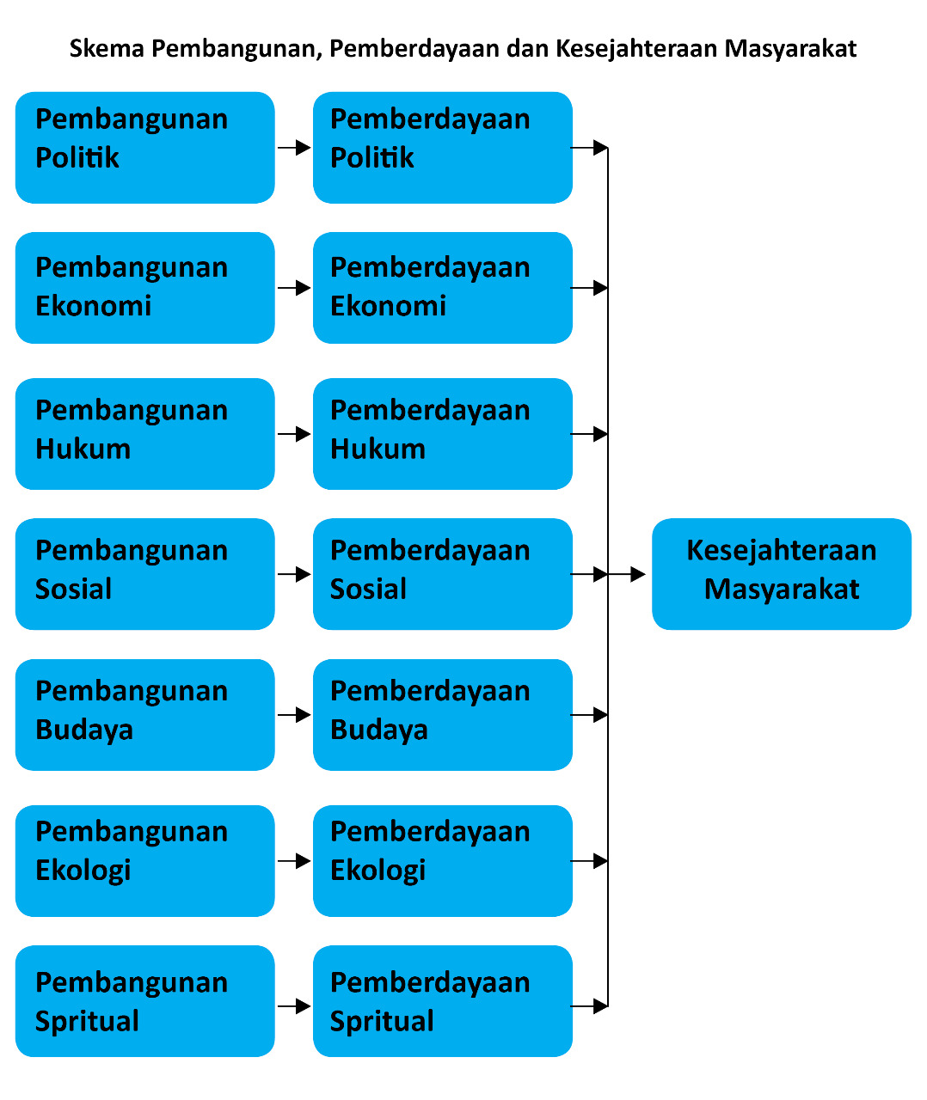
Source: Isbandi, 2002:165)

In the implementation of cross-sectoral empowerment, problems usually arise to synergize various existing empowerment efforts so that they do not conflict with each other so that the implementation of social development and community empowerment can be carried out as a whole.
EMPOWERMENT AS A PROCESS
Empowerment as a process is a continuous process throughout one's life. The extent to which empowerment as a process can be seen as stated by Hogan (2000:13) in Isbandi (2002:172) who sees the process of individual empowerment as a process that continues throughout human life obtained from the individual's experience does not stop at a time. This also applies to a society, where the empowerment process does not end with the completion of a program, whether implemented by the government or non-government. The process will continue as long as the community or society exists and is willing to try to empower itself.

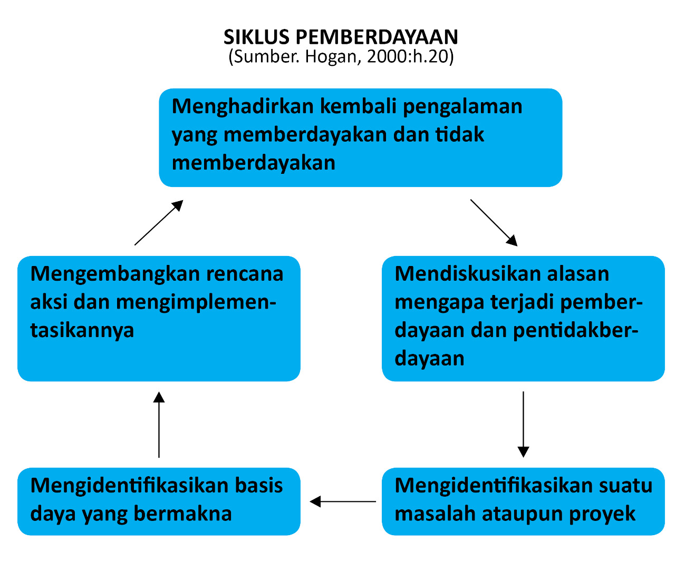
Hogan (2000: 20) describes the continuous empowerment process as a cycle consisting of five main stages that roll back to the first stage:
First, bring back empowering and non-empowering experiences (recall depowering/empowering experiences);
Second, discuss the reasons why empowerment and powerlessness occur (discuss reasons for depowerment/empowerment);
Third, identify a problem or project (identify one problem or project);
Fourth, identify meaningful power bases (identify useful power bases), and
Fifth, develop action plans and implement (develop and implement action plans).
In the above cycle Hogan focuses on individual empowerment, but the on going process empowerment model can be applied at the community level (Isbandi:175).
In the context of Social Welfare, the empowerment described by Hogan is associated with efforts to improve people's living standards, of course, by examining the factors that cause a community to be less empowered (Isbandi, 2002:175). This means that before carrying out an empowerment activity, it is necessary to analyze the causal factors before the empowerment process is carried out so that the empowerment activity or process carried out in a community or individual is right on target and in accordance with the needs of a community and has a measurable end goal because of the existence of stages or cycles in accordance with the concept of empowerment.
That the empowerment process is an on-going process does not mean eliminating problems, but that empowerment prepares structures and systems in the community so that they can be proactive and responsive to community needs and problems that exist and can arise in the community (Isbandi 2002:177). This means that an empowerment process teaches and provides an ability to the community or community or program target to be able to learn to solve problems that can occur in a community or society, because a structure and system has been formed that will assist them in solving problems.
The involvement of Youth Organizations in tourism management in Warnasari Village, Pangalengan District, Bandung Regency is a form of economic empowerment because the goal is economic development, by providing resources to youth organizations, and opportunities in order to increase their knowledge and skills. improve the social welfare of the local community. The sustainability of tourism management in Warnasari village can be carried out by residents, it will not always be held by investors, of course professionally. The management of natural tourism that involves the surrounding community can make a major contribution to improving the welfare of the community. The presence of investors can be assumed as a form of learning for village communities, especially Karang Taruna, how to manage tourist attractions in a professional manner, both managerially and technically, so that there will be sustainability. have received the knowledge, the infrastructure is already there, so it's just a matter of continuing. The management of tourism places that fully involve the village community requires clear policies from the local government.
The concept of community empowerment in tourism development, Phillips (2009), Okazaki (2008) and Chuang (2010) that community empowerment efforts through tourism should essentially be directed at several things: increasing the capacity, roles and initiatives of the tourism development community, increasing the position and quality of involvement community participation, increasing the value of the positive benefits of tourism development for the economic welfare of the community, increasing the ability of the community to travel.
The importance of empowerment in tourism management in an area other than for sustainability is for the sake of improving the welfare of the local village community, a lot happens in the field, sometimes the surrounding community does not benefit from the development of tourism in their area, but it cannot be denied that the management of tourism by the local community is not professional and developing but seems impressed. managed modestly, therefore the presence of investors is important, but then the village community must be empowered and learn to manage good and sustainable tourism. Tourism in an area must of course be seen from the side of local wisdom, therefore the participation of local communities is very important, as described by Murphy (1988), Larry Dawyer, Peter Forsyth and Wayne Dwyer (2010) in Sunaryo (2013). community-based activities, with the main factor being that the resources and uniqueness of the local community in the form of physical and non-physical elements (traditions and culture) attached to the community must be the main driving force in tourism.
In this study, the authors are interested in conducting a study on the empowerment of Youth Organizations in Tourism Management so that they can contribute to improving the economy and community welfare. Barriers and challenges of Karang Taruna in tourism management. The location of this research is in Warnasari Village, Pangalengan District, Bandung Regency which has a lot of natural potential that can be developed as a tourist spot. which has been managed by many investors and involves Karang Taruna in its management.

- Method
The method used in this research is descriptive qualitative. Research using a qualitative approach with descriptive research type, according to Bogdan and Taylor (in Moleong, 2002: 3), qualitative research methods as a research procedure that produces descriptive data, namely written or spoken words from people and observed behavior . This research data collection technique was carried out in the following ways:

- Interview (Interview)
Esterberg (2002) in Sugiyono (2015: 75) Interview is a meeting of two people to exchange information through questions and answers with related parties to obtain information and data needed, so that meaning can be constructed in a particular topic. In this study, researchers interviewed resource persons or informants who have a relationship and are expected to provide an overview and research answers. In this study, interviews were conducted with members of the youth organization, village officials, namely the village head and related ranks, the community

- Observation
According to Nasution (1988) in Sugiyono (2015:64) observation is the basis of all science. Observing directly in the environment where the research was conducted, observations in this study were conducted to see and listen to the activities and contributions of Karang Taruna to tourism in Warnasari Village, then record the observations by taking notes and using tools to facilitate observation.
- Documentation Study
Documentation is done by searching and collecting data, sources of information and materials obtained from books, literature, articles, regulations, policies.

Data analysis technique

The data analysis technique is a way of analyzing the data obtained from drawing conclusions from the conclusions of research results. The process of data analysis by examining all available data from various sources obtained from research in the field, namely interviews, observations written in field notes, personal documentation, official documents, pictures and so on (moleong, 2002:190).
The location of the research was carried out in Warnasari Village, Pangalengan District, Bandung Regency. The selection of this research area is because Warnasari Village has many tourist attractions that are very potential and very good to be developed which contribute to improving the economy of the people of Warnasari Village, Pangalengan District, Bandung Regency. As we know that the natural potential that is developed is one of the rural development efforts through the tourism sector, which not only presents unspoiled tourism resources, but also contributes to improving the economy of the surrounding community. And community involvement in this case Karang Taruna as the main controller in its development is important because Karang Taruna as one of the youth organizations is actively involved in tourism management. Informants in this study were members of the Karang Taruna of Warnasari Village who were involved in tourism management by investors who developed a lot of natural tourism in Warnasari Village, Pangalengan District, Bandung Regency. Data collection techniques in this study were carried out by means of in-depth interviews, observation, and documentation studies. This research, to answer the research objectives about the empowerment of Youth Organizations in tourism management in Warnasari Village, Pangalengan District, Bandung Regency.

- Result and Discussion
Tourism in Warnasari Village, Pangalengan District, Bandung Regency
Tourism in Warnasari village is developing rapidly, and has become one of the leading tourist destinations in Pangalengan District, namely Situ Cileunca, which is managed by investors because it is known that the management of tourist attractions requires no small amount of funds and requires people who have knowledge in the field of tourism. Tourism management is better carried out by the private sector as recommended by the Ministry of Tourism so that the management of tourist attractions is left to the private sector. The government is only to support (industry lead government support), because tourist attractions are usually always more advanced if managed privately than by the regional or central government.
SITE CILEUNCA
Situ Cileunca is one of the prima donna tourist destinations in Pangalengan District, Situ Cileunca is 45 KM south, precisely in the Warnasari and Pulosari villages, Pangalengan sub-district, Bandung district, Situ Cileunca is located at an altitude of 1550 M above sea level and is surrounded by two Malabar tea plantations managed by PTPN VIII, Situ Cileunca, located n ot far from the sub-district of Pangalengandanau, has been transformed into a tourist attraction because it presents an extraordinary natural panorama because it is equipped with a very beautiful natural mountain and hilly background. There is a camping ground nearby. Situ Cileunca is also equipped with strawberry and strawberry plantations. In addition, now this tourist attraction is connected to the Palayangan river which finally opens up flying fox and white water rafting facilities with various variants of rates and different facilities for each package.
Situ Cileunca tourism activities are generally used by the people of Greater Bandung. Outside of that, it is in the form of an agency / agency that is on vacation, so the attractions offered are specifically for tourists in groups of at least 5 people. The tourism activities offered consist of Arum Rafting, Flying Fox, Camping Ground, Boat Rentals, Paint Balls, Outbound, and Agrotourism.
Explore Situ Cileunca
In 1918, this quiet area filled with trees and wild plants was made an artificial lake above an altitude of 1550 meters above sea level, with an area of ​​about 1,400 hectares and a depth of 17 meters. Situ Cileunca is an artificial lake built by the Dutch until 1926. This lake was made for the purpose of hydroelectric power plants or hydropower. The electrical energy produced by the hydropower plant is used for the electrical energy needs of the tea factory and part of the electrical energy needs of the residents of Bandung City during the Dutch colonial era. In this main area, you can enjoy Situ Cileunca from the edge of the lake. However, if you want to go to the middle of the lake and explore each side of the lake, facilities are provided in the form of a wooden boat equipped with an engine. The price offered for this boat is around Rp. 75,000 per boat and can be filled about 10 people. That way if the boat is fully loaded, it only costs around Rp. 7,500/person. In order to get a good view for those who want to take pictures, especially for those who like photography, you should come to Situ Cileunca Pangalengan Tourism as early as possible before sunrise. Because, the view of the surface of the lake in the morning will look cooler with a thin mist over the surface of the lake water coupled with the fresh air that we can breathe. In addition, the color gradation of the red morning sky before sunrise reflects perfectly on the surface of the lake like a giant mirror.
Rafting and Outbound Pangalengan Situ Cileunca
For those who like challenges, you can try rafting or rafting rides on this tour. The location is on the Palayangan River where the water comes from Situ Cileunca. In order to enjoy this rafting ride, we usually join the tour package provided by the manager. So, you can choose packages with certain facilities with additional outbound tours such as flying fox, lodging, food, and others. Rafting Pangalengan Palayangan River is the most popular tourist activity in Situ Cileunca Pangalengan Nature Tourism.
Rafting or called rafting is a tourist activity that falls into the category of water sports. Rafting Pangalengan is a water sport that tests the adrenaline which is so stressful and gives a distinct impression. Instead, if you choose this Pangalengan rafting activity, you must really be in very prime condition. In addition to the body will be drenched, white water rafting activities also require a lot of energy. The Pangalengan Rafting fee for one trip is Rp. 185.000,- / person. The price includes the cost of the boat, guide, first aid, local transportation, consumption, and guide. Before starting rafting, all participants will be given a briefing about safety and instructions that must be followed so that the activity runs smoothly. In general, one boat can accommodate a maximum of 6 people including the instructor.
Before trying rafting in this area, first the 2 people sitting at the front practice rowing following direct instructions from the guides such as right, left, back. Meanwhile, all participants had to look down when they heard the word “Boom”, which we hear almost every time. The boat was lifted to the mainland to cross the bridge and cross to the rafting location on the Palayangan River. Rafting on the Palayangan River is level 4, has a length of 5 km and takes approximately 1.5 hours.
Starting from Situ Cileunca as a starting position. There are several types of rapids that will be passed in this Pangalengan rafting activity including the Rungkun Rafting, Ice Rafting, Sheep Rafting, Blender Rafting, Welcome Rafting, and Rodeo Rafting. Along the trajectory of the rapids we are presented with such stunning views as rubber tree forests, green tea plantations, and a very peaceful natural atmosphere. There are many rapids that will make your heart beat fast, starting from the Welcome Rapids, Blunder Rapids, and Sheep Rapids. In addition to rafting, Situ Cileunca Pangalengan Nature Tourism also provides outbound tourist facilities such as flyng fox, archery, Pangalengan tours and also paint ball games which are often done by tourists. This activity adds to the attractiveness of Situ Cileunca, besides being able to enjoy its unique nature, you can also play games that are useful for gluing relationships between work teams. So it's not surprising that most tourists who carry out this activity are those who come from companies or organizations and government service units. In addition, the manager also provides the price for the Outbound Fun Gathering package.

CAMPING THERE CILEUNCA AND THE BRIDGE OF LOVE
Besides the lake, there are camping tours so that tourists can feel the atmosphere there at Cileunca at night. Camping by the lake will be a memorable experience for those who live in an urban environment. In the morning when we wake up from sleep, the cool air typical of Pangalengan will definitely accompany us when we decide to spend the night at Situ Cileunca. But there is no need to worry about being bothered by bringing camping equipment, at Situ Cileunca there is a Citere Camping Ground which provides all camping facilities such as tents, mattresses, lighting, cooking utensils, firewood, and so on. The Camping Ground citere is also equipped with bathroom and toilet facilities equipped with a shower. For those who visit with family or colleagues, don't let this moment be missed. If you have a hobby of fishing, while the camp can spend time fishing for freshwater fish on the shores of the lake, then burn them with friends. There are packages for
One more thing that makes Situ Cileunca interesting is the existence of the Love Bridge. What is the form of love? Or near a heart-shaped island? Certainly not. It is called the Bridge of Love because every afternoon many couples visit the Bridge of Love. Another reason is because the Bridge of Love connects the two villages, so many couples from the two villages are separated and end up meeting at the Bridge of Love. The Cinta Bridge was originally built by the village government on Situ Cileunca, intended to help the mobility and economy of residents between the two islands. For those of you who like photography, don't miss this moment because there are many artistic angles that will produce beautiful photos.
Equipped with a very beautiful natural background of mountains and hills. Around Situ Cileunca there is also a very pleasant campsite. Situ Cileunca Pangelangan is also connected to the Palayangan River which finally opens the way for you to flying fox and white water rafting facilities with various tariff variants and different facilities for each package. The cluster of mountains to the east looks majestic and sturdy, namely Mount Wayang and Mount Windu and the puff of smoke that comes out of the geothermal energy in the Wayang Windu Geothermal Power Plant area also adds to the beauty of the scenery around Situ Cileunca. So what are you waiting for? Feel the sensation at Situ Cileunca Pangelangan Nature Tourism with your partner, friends, and colleagues.

CILEUNCA SITU AS A SOURCE OF CLEAN WATER AND POWER PLANT
In addition, visitors can get around by boat to circle the lake. For visitors who like adrenaline-challenging activities such as rafting, the water from the Cileunca dam is usually used for these activities. Besides being used for tourism, Situ Cileunca water is also used as a source of clean water for the residents of Bandung and as a power plant.
Youth Organization Empowerment Empowerment in Cross-Sectoral Tourism Management
The Karang Taruna (Youth) Empowerment Program in managing tourism in Warnasari Village, Pangalengan District, Bandung Regency is actually not only aimed at Karang Taruna members but also for the people in Warnasari Village. This is done so that the community takes part in improving the economy of the community in Warnasari Village, Pangalengan District, Bandung Regency. When tourism develops, it indirectly provides another source of livelihood, namely in the tourism sector which is expected to be enjoyed by residents of Warnasari Village, Pangalengan District, Bandung Regency, whose livelihoods are mostly as farm laborers, which is 45.40%.
Youth empowerment in tourism management in Warnasari Village, Pangalengan District, Bandung Regency is cross-sectoral empowerment, namely economic, ecological, social and spiritual. One that is being developed is by utilizing the potential of nature to develop tourist attractions. These efforts are not only to increase the use value and economic benefits for Karang Taruna in particular, generally to local community members, for example home industry women who produce Pangalengan special foods that can be used as souvenirs when they visit tourist attractions in Warnasari Village, in addition to Therefore, by utilizing nature for tourism, the community is also encouraged to take care of the environment/ecology to be more beautiful so that nature tourism is growing with the preservation of the environment. As we know, Warnasari Village, Pangalengan District, has a lot of natural potential that can be developed for tourism (Cileunca Lake, tea plantations, milk-producing cow farms). Developing tourism cannot be separated from social and spiritual empowerment, because it must pay attention to social values ​​in the village community, always maintain local wisdom, cultural and religious customs Tourism development can be accepted by the community of Warnasari village, because on the one hand the development of tourism is good for improving the community's economy, but tourists coming from outside the area bring many positive and negative side effects for the community in value, spiritually and socially.
Youth Youth Empowerment in Tourism Management as a Process
Empowerment of Youth Organizations in tourism management by investors in Warnasari Village, Pangalengan District, Bandung Regency is a process that is carried out continuously through individuals and their communities, namely Karang Taruna technical management is not yet at the managerial level, because in terms of knowledge they are not yet qualified and do not have expertise in managing places. tourism, so that Karang Taruna is only involved in managing the infrastructure and technical level, for example being a tour guide for tourists, being included in the development of tourism potential in the Warnasari village, for example by exploring the natural potential in the Warnasari village area which will be used as a new tourist spot.

SIKLUS PEMBERDAYAAN KARANG TARUNA DESA WARNASARI
Karang Taruna melihat apa saja yang memberdayakan dan apa yang tidak (kembali melihat sejauhmana kemampuan dan keterampilan yang mereka miliki sehingga mereka berdaya, dan melihat kembali sisi lemah dari Karang Taruna yang membuat merasa tidak diberdayakan secara maksimal

Setelah mengidentifikasikan masalah, potensi dan peluang yang dimiliki Karang Taruna, selanjutnya mengembangkan rencana aksi kemudian melaksnakannya
Mendiskusikan kembali alasan mengapa Karang Taruna harus diberdayakan dan kenapa tidak diberdayakan. (Potensi Karang taruna sebagai organisasi kepemudaan yang dianggap mampu untuk membawa perubahan dan bisa meningkatkan kesejahteraan masyarakat)

Setelah mengidentifikasikan masalah yang menjadi hambatan, selanjutnya mengidentifikasikan apa saja yang menjadi kekuatan atau kelebihan yang dimiliki Karang Taruna sehingga bisa menjadi basis/modal dalam pemberdayaan
Dari diskusi selanjutnya diidentifikasikan masalah yang dihadapi yang menjadi hambatan bagi Karang Taruna sehingga pemberdayaan dilakukan (kurangnya pengetahuan dan keterampilan,

Sumber : Hogan, 2000:20)
Hasil analisis: Peneliti
The Role of Change Agents as Community Workers
The agents of change in this study are village officials and investors who manage tourism in Warnasari Village, Pangalengan District, Bandung Regency.
There are 4 (four) major roles that can be carried out as a community worker:
- Facilitative roles, namely facilitating the target community in this case Karang Taruna by providing support and utilizing resources and skills, namely by identifying and utilizing various skills that exist in the community or group. As a target group, Karang Taruna is seen as having tremendous potential in exploring new natural attractions that can be developed, for example in addition to rafting rides that already exist, camping tours, photo spots with natural panoramas are starting to open. In addition, utilizing skills in the home industry as part of the promotion of Warnasari village tourism, so that the impression is that because the management of tourist attractions is carried out by investors so that they do not feel they have ownership and do not see opportunities for them to get more benefits, especially in improving the economy in management. tourist attraction.
- Educational roles, namely the role of educating the target community in this case Karang Taruna indirectly by involving them in tourism management in the Warnasari Village, Pangalengan District, Bandung Regency. they get in terms of professional tourism management.
- The role of community representatives (representational roles), which includes:
  - Seeking resources (obtaining resources) by recruiting Youth Organizations to be involved in tourism management.
  - Utilizing media (using media) for tourism promotion and that has been done in collaboration with Karang Taruna and travel agents in order to promote tourism objects in Warnasari Village through social media (https://infopromodiskon.com, Instagram official situ cileunca (@situcileunca) ), twitter @Situ_Cileunca)
  - Public relations by always coordinating with village administrators and the community.
  - Developing networks (networking), in developing tourism in Warnasari Village, Pangalengan District, Bandung Regency, investors/village officials as community workers are obliged to develop networks so that tourism advances, because the progress of tourism in Warnasari Village, Pangalengan District, Bandung Regency will certainly have a positive impact on all parties (empowered communities as well as investors and village officials as empowerers or agents of change.
  - Sharing knowledge and experience, knowledge is very important in managing tourism well so that it progresses and develops, but experience is the best teacher, because from experience we can know various things that happen in the field so that in overcoming problems there are no difficulties.
- The technical role is to include community empowerment skills in managerial terms, the technical role is not unimportant but rather to internal empowerment, not directly related to the community.

Of the four roles described above have not been ideally implemented, but many efforts have been made and all are empowerment efforts which are expected to improve the economy of the community in Warnasari Village, Pangalengan District, Bandung Regency.

OBSTACLES AND CHALLENGES
As a forum for youth, Karang Taruna has various problems and obstacles in the implementation of tourism management. Based on field data and in-depth interviews, the main obstacles to youth organizations come from internal and external. Internal barriers to youth activities include skills and knowledge that are not possessed by most members of the Youth Organization, for example in terms of foreign language skills (English), low ability in mastering technology, low mastery in managerial, so they are only involved in technical matters at the youth level. only in the field, for example being a tour guide for rides in tourism places. The external obstacles come from institutions or institutions related to the potential development of Youth Organizations. According to the Karang Taruna management, the main obstacle is the lack of support from policy makers regarding how to get Karang Taruna to gain more knowledge, for example foreign language training, because paying for it yourself is not a priority for them. So far, Karuna Taruna's activities have not been heard because of the lack of funds. The involvement of Karang Taruna in tourism management in Warnasari Village, Pangalengan District, Bandung Regency is an effort to increase the economic capacity of its members in particular, as well as the community at large, and that is a long-term goal in the empowerment process, making the target group namely Karang Taruna less empowered to have the power to achieve a better life.
Empowerment of Youth Organizations in tourism management by investors in Warnasari Village, Pangalengan District, Bandung Regency is a process that is carried out continuously through individuals and their communities, namely Karang Taruna technical management is not yet at the managerial level, because in terms of knowledge they are not yet qualified and do not have expertise in managing places. tourism, so that Karang Taruna is only involved in managing the infrastructure and technical level, for example being a tour guide for tourists, being included in the development of tourism potential in the Warnasari village, for example by exploring the natural potential in the Warnasari village area which will be used as a new tourist spot.
In the implementation of Karang Taruna empowerment in tourism management in Warnasari Village, Pangalengan District, Bandung Regency, there are several obstacles faced by Karang Taruna, namely managerial abilities that are not owned by Karang Taruna, as well as limitations in mastering foreign languages ​​(English), because according to information from Karang Taruna members if there are foreign tourists who come then they will hire translators from outside the Warnasari Village and it costs quite a bit, so the income they get is reduced and is greater for paying translators so that it is quite an obstacle in the implementation of Karang Taruna activities as tour guides. In addition to barriers in foreign language skills, most of the Karang Taruna members lack mastery of technology. In addition to obstacles, there are several challenges for Karang Taruna in tourism management, namely how to grow a professional spirit and have a good work ethic so that there is a desire to learn new things in tourism management so that the capacity of Karang Taruna members increases. The next challenge is the weakness of the youth organization in optimizing the potential of its members, which is a problem that cannot be ignored. This is because of the lack of bargaining power that seems promising in this youth organization, so that the younger generation cannot see the importance of being in this organization.

4. Conclussion
From the results of the discussion in this study there are several conclusions and suggestions that researchers get:
- Tourism management in Warnasari Village, Pangalengan District, Bandung Regency, specifically the management of Situ Cileunca is quite good, this is proven by the increasing number of existing rides.
- Tourism in Warnasari Village, Pangalengan District, Bandung Regency has not yet fully provided a direct economic improvement impact that is felt by its citizens, because its management by investors or called city people, the community does not feel directly involved.
- The involvement of Karang Taruna in tourism management in Warnasari Village is only partial, so that the ability of Karang Taruna in terms of tourism management is difficult to develop and the goal of empowerment in the economic field is still not maximized.
- Constraints experienced by Karang Taruna in the involvement of tourism management include aspects of regulations and policies from local village officials who are not strong in the provisions for investors to involve Karang Taruna fully and not partially. So it is hoped that the local community has an equally important position as one of the stakeholders in tourism development, in addition to the government and private industry.
- Empowerment of Youth Organizations in tourism management in Warnasari Village must use a strategy and have clear targets for achievement, so the extent to which Karang Taruna is involved and the targets to be pursued in this empowerment must be clear.
- The ability to master knowledge and skills in language and technology must continue to be trained, for example by holding training for Youth Organizations initiated by village officials and facilitated by investors.
Suggestion
- From the results of the study, it can be seen that the knowledge and skills of Karang Taruna are weak, so this can be used as a reference for investors to provide adequate training so that the role of Karang Taruna is greater and there is an increase in the capacity of Youth Organizations which is certainly useful for their sustainability.
- Constraints faced in each region may be different, through the results of this study it can be taken into consideration in implementing programs in other regions by first examining the obstacles that may be faced and the factors that will influence them.
- To complete this research, it is necessary to conduct further research on the empowerment of Youth Organizations in increasing their capacity.

Refferences
BOOKS
Ife, Jim (1995) Community Development, Creating Community Alternatives-Vision, Analysis and Practice. Melbourne:Addison Wesley Longman Australia Pty Limited.
Adi, Isbandi Rukminto. (2002). Pemikiran-pemikiran dalam Pembangunan Kesejahteraan Sosial. Jakarta: Penerbit FE-UI.

Lexy J, Moleong. (2002). Metode Penelitian Kualitatif. Bandung: PT. Remaja Rosdakarya

Chuang, Shu-Tzu. (2010). “Rural Tourism: Perspective from Social Exchange Theory”. Social Behavior and Personality Journal. Volume 38, Nomor 10, Halaman 1313. Taiwan: Society for Personality Research (Inc.).

Sunaryo, Bambang. (2013). Kebijakan Pembangunan Destinasi Pariwisata Konsep dan Aplikasinya di Indonesia. Yogyakarta: Gava Media.

Sugiyono (2015), Moleong. Metode Penelitian Kombinasi (Mix Method). Bandung: Alfabeta

JOURNAL

Tisnawati, Indah, dkk. “Strategi Pengembangan Eko-Wisata Berbasis Masyarakat Di Kampung Wisata Rejowinangun”. INERSIA, Vol. XV No. 1, Mei 2019

Suprayoga, dkk. “Model Pemberdayaan Karang Taruna Di Kecamatan Cerme Kabupaten Gresik”. AJIE- Asian Journal of Innovation and Entrepreneurship, Vol. 01, No. 02. Mei 2016
Khaldun, Rendra. “Pemberdayaan (Pemuda) Karang Taruna dalam Meningkatkan dan Menumbuhkan Minat Bisnis Kreatif di Desa Giri Madia Kecamatan Lingsar Kabupaten Lombok Barat” Jurnal Transformasi, Vol. 12 No. 2, Juli 2016: 168-185.

Oktavian, Alif, dkk. “ Pengembangan Kemampuan Tour Guide Desa Warnasari Kecamatan Pangalengan Kabupaten Bandung”. Jurnal Kaibon Abhinaya. Jurnal Pengabdian Masyarakat. http://dx.doi.org/10.30656/ka.V1i2.1686

Patimah, Siti, dkk. “Pemberdayaan Pelaku Usaha Melalui Pengelolaan Usaha Wisata di Desa Warnasari Kecamatan Pangalengan Kabupaten Bandung” Kaibon Ahinaya. Jurnal Pengabdian Masyarakat. http//:dx.doi.org/10.30656/ka.v1i2.1690

Aqilah N. K Latif, dkk. “Analisis Perubahan Permukiman Akibat Pariwisata di Kawasan Wisata Situ Cileunca Kabupaten Bandung”. Jurnal Lingkungan Binaan Indonesia 8 (2), 70-78. http://doi.org/10.32315/jlbi.8.2.70

WEBSITES
https://www.warnasari.desa.id/index.php/artikel/2018/11/21/panorama-situ-cileunca
https://mediaindonesia.com/ekonomi/60290/pengelolaan-tempat-wisata-sebaiknya-dipegang-swasta dikutip 29 Juli 2021
https://infopromodiskon.com/tempat-wisata/profile/wisata-situ-cileunca-pangalengan-bandung/

GOVERNMENT DOCUMENTS
Peraturan Menteri Sosial RI No. 77/HUK/2010 tentang Pedoman Dasar Karang Taruna
Undang – Undang No. 10 Tahun 2009 tentang Kepariwisataan

