ECONOMIC EMPOWERMENT THROUGH BUYING INTENTION ON ONLINE MARKETING IN INDONESIA
Deden Novan Setiawan Nugraha
Faculty of Business and Management, Widyatama University
deden.novan@widyatama.ac.id

Abstract
Community economic empowerment is an effort to make the economy strong, large, modern and highly competitive in the right market mechanism. The constraints of people's economic development are structural constraints; the empowerment of the people's economy must be carried out through structural change. One of them is structural change through technology by online shopping application. The purpose of this research is to find out how the influence of online marketing variables which consist of Personal Relevance, Online Interactivity, Message, and Brand Familiarity Brand towards buying intention. In this study, researchers took objects on the online shopping application Qlapa.com which specifically sells handmade products. The sampling technique used by researchers is a non-probability sampling technique, because not all samples have criteria which are in accordance with what the researcher determined. Based on the calculations made, the sample used in this study was 100 people. The research method used in this research is quantitative methods. The analysis was conducted using the method of multiple regression analysis to explain the effect of the variables. The problems examined in this study are Personal Relevance (X1), Online Interactivity (X2), Message (X3), Brand Familiarity (X4), and Buying Intention (Y). The results of the study found that simultaneously and partially the variables Personal Relevance, Online Interactivity, Message, and Brand Familiarity have a significant influence on buying intention.
Keywords: Economic Empowerment, Personal Relevance, Online Interactivity, Message, Brand Familiarity, Buying Intention.

- Introduction
The potential development of Micro, Small and Medium Enterprises (UMKM) in Indonesia is inseparable from banking support in lending to Micro, Small and Medium Enterprises (UMKM). Every year credit to Micro, Small and Medium Enterprises (UMKM) experiences higher growth than total bank loans. The number of Micro, Small and Medium Enterprises (UMKM) industry entrepreneurs in Indonesia is the higher than other the countries, especially since 2014. Micro, Small and Medium Enterprises (UMKM) are one of the economic drivers. According to Yunita Resmi Sari, Head of Bank Indonesia (BI) Micro, Small and Medium Enterprises (UMK) Development Department, currently the condition of Micro, Small and Medium Enterprises (UMKM) in Indonesia dominates business units to 99.9% of the total 57.89 million with a significant contribution to employment absorption of 96.9% and GDP of 57.56 % and exports 15.68%. The ability of Micro, Small and Medium Enterprises (UMKM) in building the Indonesian economy is caused by excellence in several factors, there are specific focus capabilities, national flexibility, low costs and the speed of innovation. Another thing that must be considered in order to encourage Indonesian Micro, Small and Medium Enterprises (UMKM) to market more broadly is ease of access in capital and marketing assistance. In addition, restrictions on imported products are also an important part in helping Micro, Small and Medium Enterprises (UMKM) to continue to compete. If imports are not addressed, it is certain that Micro, Small and Medium Enterprises (UMKM) products cannot compete because of the cheaper prices of imported products.
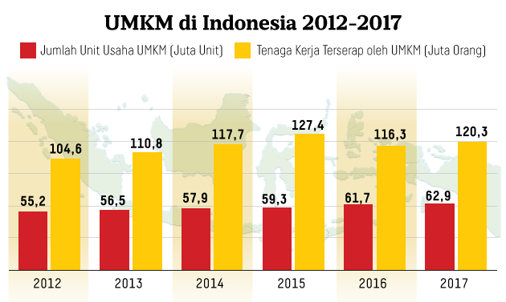
Source: Ministry of Cooperatives and Small and Medium Enterprises
Figure 1. The Number of Micro, Small and Medium Enterprises (UMKM)
and Labor Absorption in 2012 -2017

Based on data released by the Ministry of Cooperatives and Small and Medium Enterprises it is known that the number of Number of Micro, Small and Medium Enterprises (UMKM) business units continues to experience growth from year to year. In 2012 the number of MSME business units was 55.2 million units, while in 2017 the number of MSME business units was 62.9 million units. This means that within a period of 5 years the number of Number of Micro, Small and Medium Enterprises (UMKM) business units has grown by 7.7 million units. This certainly has a positive impact on the Indonesian economy, especially in decreasing unemployment and labor absorption which has also increased despite a decline in 2016, but not significantly.
The Micro, Small and Medium Enterprises (UMKM) business unit contributes to employment, gross domestic product (GDP) to exports. Based on data from the Central Statistics Agency (BPS), it was recorded that 3.79 million Micro, Small and Medium Enterprises (UMKM) had used digital technology or e-commerce businesses. This number is around 8 percent of the total Micro, Small and Medium Enterprises (UMKM) players in Indonesia, which is 59.2 million. Most Micro, Small and Medium Enterprises (UMKM) use the main market place platform in Indonesia. As many as 57.21% of respondents use e-commerce services or online marketplace to increase product sales traction. Sorted from the most used, the most widely used sites are Tokopedia (68.7%), Bukalapak (58.26%), Shopee (42.61%), Lazada (37.39%), BliBli (18.26%), and other sites (16.52%). Therefore, efforts to utilize and optimize the use of digital technology for cooperative businesses and Micro, Small and Medium Enterprises (UMKM) through various policies and programs in developing cooperatives and Micro, Small and Medium Enterprises (UMKM) towards digital economy.
Although Micro, Small and Medium Enterprises (UMKM) in Indonesia dominate business units up to 99.9% of the total 57.89 million with a significant contribution to employment absorption 96.9% and GDP 57.56% and exports 15.68%. However, foreign products still control around 60% of the e-commerce market. The share of Micro, Small and Medium Enterprises (UMKM) has only reached 40% so a massive increase needs to be made. The Minister of Communication and Information stated that the value of e-commerce transactions in 2013 reached Rp130 ​​trillion. From these data it can be seen that the e-commerce market is very potential and e-commerce-based companies must implement the right strategies in order to excel in the e-commerce industry. This figure is not surprising, because based on data from the Neisen Global survey of e-commerce in 2014, internet users in Indonesia spent more than five hours each day accessing the internet. Four out of 15 internet users in Indonesia access e-commerce sites or shop online one to three times every week. Within a month, online buyers on average will spend at least once a month. Based on data released by the TNS Indonesia E-Commerce Survey in 2014, it appears that online shopping behavior of internet users in Indonesia is very compatible with the characteristics of handmade products because 78% of items purchased are fashion (eg clothing, bags, shoes, accessories and others).
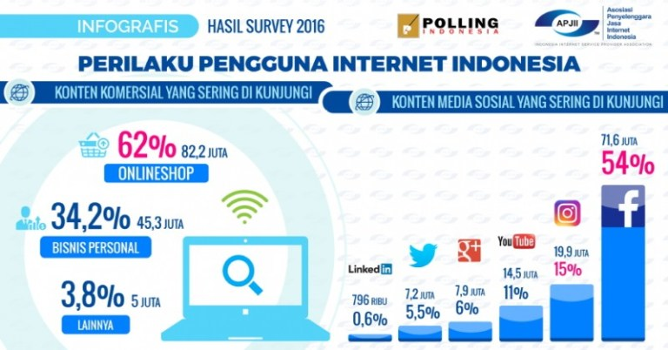
Source: Association of Indonesian Internet Service Providers (APJII)
Figure 2. Indonesian Internet User Behavior in 2016

Based on the most frequently visited content, internet users most often visit the online web shop at 82.2 million or 62%. And the most visited social media content is Facebook with 71.6 million users or 54% and second place is Instagram with 19.9 million users or 15%. One of the online buying and selling sites with Indonesian handmade products that is currently developing in Indonesia is Qlapa.com which was founded by Benny Fajarai as (CEO) and Fransiskus Xaverius as (CTO). Qlapa was established on November 1, 2015. Qlapa.com is an online buying and selling site for handmade and handicraft products such as wood furniture, jewelry, hanging ornaments, paintings, leather wallets and other handmade products. Qlapa.com now accommodates more than 4,000 Micro, Small and Medium Enterprises (UMKM) that offer hundreds of thousands of local Indonesian handicraft products, with a collective turnover of billions of rupiah every month. The products sold on this site are unique and quality creative local products with national and international market objectives. Qlapa.com has thousands of handicraft products from hundreds of sellers.

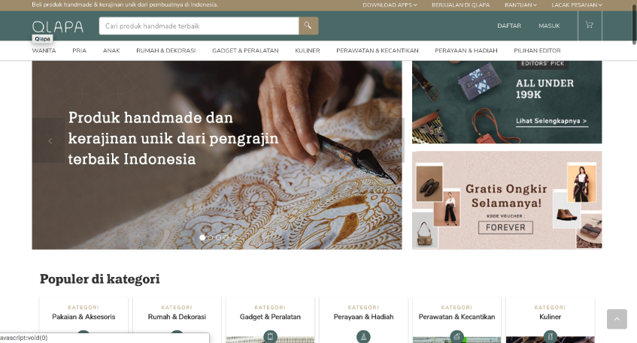
Source: Qlapa.com
Figure 3. Website Views of Qlapa.com

Based on the startup ranking site (startupranking.com) in 2018, Qlapa.com was ranked 72 in Indonesia and ranked 1,369 globally. It can be seen that Qlapa.com is still losing or below with other online buying and selling sites such as Blibli or Bukalapak.com in Indonesia. The Qlapa.com shop industry is experiencing ever-increasing growth. This growth is marked by the increasing number of new players in the industry. The number of Micro, Small and Medium Enterprises (UMKM) that have penetrated the e-commerce sector is still relatively low. According to the general chairman of the Chamber of Commerce and Industry (KADIN) Mr. Rosan Roeslani, the percentage of local products sold by the marketplace stalls in Indonesia in general only reaches 6-7%. The number of Micro, Small and Medium Enterprises (UMKM) must get support to be able to explore the potential of digital marketing and develop Indonesia's economy. Thus, in this study a conceptual model and implementation strategies for Personal Relevance, Online Interactivity, Message, and Familiarity Brand will be developed in an effort to influence Buying Intention on Qlapa.com.

2. Theoretical Framework
Economic Empowerment
According to Merriam Webster and Oxford English Dictionary in Hutomo (2000) the word empower contains two meanings, there are: (1) to give power or divert power or delegate authority to other parties; (2) effort to give ability or empowerment.
Some literature states that the concept of empowerment has been born since industrial revolution or there is also a mention since the birth of modern Europe in the century18 or renaissance era, that is when people begin to question determinism religious. The concept of empowerment began to become a development discourse, when people started question the meaning of development. In Europe, the discourse of empowerment arises when industrialization created a ruling society of factors of production and society which controlled workers. In developing countries, the discourse of empowerment arises when development raises social interaction, economic inequality, natural resource degradation, and community alienation from the factors of production by ruler.
Empowerment is making a local community own initiative or idea and ability to implement the initiative with their own abilities. The concept of empowerment is not only individual but collective (individual self-empowerment and collective self-empowerment), and all of that must be part of self-actualization and co-actualization human existence and humanity. In other words, humans and humanity is the normative, structural, and substantive benchmark. Economic empowerment can be defined as an effort to making the economy strong, big, modern, and highly competitive in the right market mechanism. The definition explains that empowerment is a process and purpose. As a process, empowerment is a series of activities to strengthen power or empowerment weak groups in society, including individuals experiencing poverty problems
Suharto (2010) in Komang (2018:33) argue that Empowerment includes various aspects where economic empowerment is one of the concept of empowerment that became the focus of the Indonesian government as a form of efforts to reduce poverty. Economic empowerment is the empowerment of the community that includes the provision of venture capital, training of productive economic enterprises, the formation of social markets and cooperatives, training and fostering of independent young families, fostering community social participation, fostering children and adolescents.
While Hutomo (2000) in Komang (2018:34) states that Economic empowerment of society one of which can be realized in the form of business capital and training of productive economic enterprises in order to realize social markets and cooperatives, to realize poor families able to be independent and economically empowered. Economic empowerment is put forward as follows: 1. People's economy is an economy organized by the people. The economy organized by the people is a national economy rooted in the potential and power of society at large to run their own economic wheels. 2. Economic empowerment of the people is an attempt to make a strong economy, big, modern, and highly competitive in the correct market mechanism. Because the constraints of people's economic development are structural constraints, the people's economic empowerment must be done through structural change.

Marketing Management
The role of management is very large on the success of a business enterprise, management is one of the important and essential sciences needed by every company. Management is a privilege in dealing with time and human relations problems when they arise in organizations or companies. Lots of experts express differing opinions, but in principle they have the same aims and objectives. According to researcher management is a process of direction from the provision of facilities to the work of people organized in the organization. Management is also an activity that is based on science and art to achieve predetermined goals with the help of others in achieving organizational or group goals, and also a process of a series of activities so that the implementation of work can take place effectively and efficiently. Marketing is one of the main activities that need to be done by a company whether it is a company of goods or services in an effort to gain profits and to maintain the viability of the business.
Some marketing experts such as John W. Mullins and Orville C. Walker (2013: 14) suggest marketing is a social process that involves activities needed to enable individuals and organizations to get what they need and want through exchanges with others and to develop exchange relations sustainable. Whereas according to Kotler and Armstrong (2015: 30) marketing is a process where companies create value for customers and build strong relationships with customers to get value from customers in return. Furthermore, Kotler and Keller (2016) marketing is about identifying and meeting human and social needs. One of the shortest definitions of good marketing is to fulfill needs profitably. Referring to the previous definitions, the writer concludes that marketing management is the art and science of choosing target markets designed to create and maintain profitable exchanges to achieve company goals, namely profile and sustainability. In marketing, interaction is needed between the elements in it to achieve the stated goals.

Online Marketing
According to Djiptono, Chandra (2012: 343) integrated marketing communication is a development of the promotion term. The word promotion connotes a one-way information flow. Precisely from the delivery of marketers' messages to recipients of messages or potential customers. Instead marketing communication emphasizes two-way interaction. Consequently, promotion is perceived as a form that is mass, while integrated marketing communication is more personal or individual. At this time there have been changes in marketing activities, where marketing currently places more emphasis on activities carried out digitally. In general, something that is said to be online is when it is connected in a network or a larger, or more specific system known as a general conversation on, network or network. In this context it is usually more directed to internet facilities so that online is more about explaining the status that it can be accessed via the internet.
Online can be said to be connected, active which is ready for communication and controlled by the computer. Online can also be interpreted as a situation where a device (computer) is connected to other devices so they can communicate with each other. Online marketing according to Kotler and Keller (2016) is marketing carried out through an interactive online computer system, which connects buyers and sellers electronically. In conducting online marketing activities there are several factors that influence it, namely (1) Personal Relevance "Personal relevance can influence a person's behavior towards buying interest through online media. Judging from the research conducted, they get results that further personal relevance has an influence on the consumer decision-making process individually ". (2) Online Interactivity Tjiptono, Chandra (2012: 381) "Online interactive allows a high level of customer involvement of certain site visitors usually those who are quite interested in the company or product visited by the site". (3) Message Tjiptono, Chandra (2012: 381) "Message ie messages can be specifically designed according to the needs and desires of the target audience specifications". (4) Brand Familiarity "In accordance with the results of research by Bamba and Barnes (2007), they explained a variable that greatly affects consumers who shop online. Among them are brand familiarity, which is a very familiar brand that will definitely have a positive response than we see with a new brand. "

Buying Intention
One form of consumer behavior is the interest or desire to buy a product or service. The form of consumers from buying intention is potential consumers, that is consumers who have not made a purchase action in the present and are likely to take action to buy in the future or can be called a prospective buyer. Buying intention is something that is obtained from the learning process and thought processes that form a perception. Ashari (2012: 32) reveals that buying intention is the desire to have a product of buying interest will arise if a consumer has been affected by the quality and quality of an information product about the product and the weaknesses and advantages of the product compared to other brands. Simamora (2011: 106) says that buying interest in a product arises because of the basis of trust in the product which is accompanied by the ability to buy products. Therefore, it can be concluded that buying interest will arise when an individual's interest in a product is observed and is accompanied by the ability of the individual to make a decision to buy the product.
3. Methodology
In this study, the researcher took the object on the product at Qlapa.com. The sampling technique used by the researcher is a non probability sampling technique. According to Sugiyono (2017: 122) non probability sampling is a sampling technique that does not provide the same opportunity / opportunity for each element or member of the population to be chosen as a sample. The reason for selecting the sample using purposive sampling is because not all samples have criteria that are in accordance with the authors specify. for example, as for the criteria of the researcher, one of them is all consumers who have bought and made repeat purchases. Based on the calculations made, the sample used in this study is 100 people. The research method used in this study is to use quantitative methods. The analysis is done by validity test, reliability test and on data sourced from the primary data (questionnaire) that has been shared. Then the results of this questionnaire will produce data that will be analyzed by the method of multiple regression analysis. Data processing is done using SPSS 24.00. To clarify the variables studied, from what was formulated in the description above, that the subject matter under study is Personal Relevance (X1), Online Interactivity (X2), Message (X3), and Brand Familiarity (X4) and Buying Intention (Y).

4. Result and Discussion

Results of Multiple Regression Analysis
From the test results, it is known that the multiple regression equations formed are as follows:
Y = 0.046 + 0.129X₁ + 0.261X₂ + 0.158X₃ + 0.312X₄ + e
Based on the multiple regression equation, the meanings can be interpreted as follows:
- if the variable Personal Relevance (X1), Online Interactivity (X2), Message (X3), and Brand Familiarity (X4) are equal to zero (0) and permanent, buying intention is 0.046.
- The regression coefficient of the Personal Relevance variable (X1) is positive at 0.129, which means that every increase in 1 Personal Relevance (X1) variable unit will increase buying intention by 0.129 units.
- The regression coefficient of the Online Interactivity variable (X2) has a positive sign of 0.261, which means that every increase in 1 Online Interactivity (X2) variable will increase buying intention by 0.261 units.
- The regression coefficient of the Message variable (X3) is positive at 0.158, which means that every increase in 1 Message variable unit (X3) will increase buying intention by 0.158 units.
- The regression coefficient of the Brand Familiarity variable (X4) is positive at 0.312, which means that every increase in 1 Brand Familiarity (X4) variable unit will increase buying interest by 0.312 units.

Determination Coefficient Test Results

Model Summary
Model | R | R Square | Adjusted R Square | Std. Error of the Estimate
1 | .683ª | .649 | .649 | .218
a. Predictors: (Constant), X4, X2, X3, X1

Based on the results of testing the coefficient of determination, the researchers found that the variables in this study consisting of Personal Relevance (X1), Online Interactivity (X2), Message (X3), and Brand Familiarity (X4) have been able to explain variations in buying intention the remaining 64.9 percent is determined by other variables outside the research model.

Hypothesis Testing Results F

ANOVAª
Model |  | Sum of Squares | df | Mean Square | F | Sig.
1 | Regression | 40.185 | 4 | 28.027 | 18.880 | .000^{b}
 | Residual | 14.855 | 95 | .158
 | Total | 55.040 | 99
a. Dependent Variable: Y
b. Predictors: (Constant), X4, X2, X3, X1
Based on the results of testing F hypothesis, it can be seen that the F value of statistics is 18.880 while F table with a significance level of 5% is obtained by F table of 2.47. In this test, the value of F-count or F-stat is greater than the f-table value and the significance value produced is smaller than 0.05. The test results show that there are significant influences between the variables Personal Relevance (X1), Online Interactivity (X2), Message (X3), and Brand Familiarity (X4) simultaneously towards Buying Intention (Y).

Hypothesis Testing Results t

Coefficientsª
Model |  | Unstandardized Coefficients |  | Standardized Coefficients | t | Sig.
 |  | B | Std. Error | Beta
1 | (Constant) | .046 | .169 |  | .554 | .488
 | X1 | .129 | .023 | .076 | 2.329 | .036
 | X2 | .261 | .144 | .167 | 1.996 | .015
 | X3 | .158 | .042 | .133 | 3.054 | .028
 | X4 | .312 | .014 | .178 | 2.771 | .041
a. Dependent Variable: Y
From the results of the tests conducted partially, there is a significant influence between the variables Personal Relevance (X1), Online Interactivity (X2), Message (X3), and Brand Familiarity (X4) to the Purchase Intention (Y). This is known because the value of t-count / t-stat from each variable is higher than t-table. The t-count / t-stat values ​​of each variable are (2,329), (1,996), (3,054), and (2,771)> t-table (1,985).

Discussion
From this research, it was found that Personal Relevance, Online Interactivity, Message, and Brand Familiarity simultaneously had an influence on buying interest. The significance value produced is less than 0.05. Thus the magnitude of the influence of Personal Relevance (X1), Online Interactivity (X2), Message (X3), and Brand Familiarity (X4) on buying intention (Y) is 64.9% while 35.1% is influenced by other factors outside the variable examined.
Online marketing which consists of four dimensions (Personal Relevance, Online Interactivity, Message, and Brand Familiarity) if able to be maximized properly by the manager, based on the results of research can make consumers become interested in making purchases. Information in an advertisement is important (Le and Nguyen, 2014). The level of relevance of advertising to individuals influences consumer attitudes towards advertising. The higher the relevance of the ad with consumer preferences, it will reduce the level of adversity and make the ad more effective (O'Donnell and Cramer, 2015). Consumer acceptance will be greater for ads that are relevant to style. The higher the level of personal relevance, the better the attitude of consumers, and vice versa. Online interactive allows a high level of customer involvement for certain site visitors, usually those who are quite interested in the company or product visited by the site. Suitability of messages is very important and of course must be in accordance with the needs and desires of the target audience specifications. The Brand Familiarity greatly influences consumers in shopping online, because a very brand familiar will definitely have a better response compared to unfamiliar brands.
The results of the study indicate that there is a significant influence between Personal Relevance (X1) on buying intention in a positive direction. Where the significance value produced is smaller than 0.05, which is equal to 0,000. This result has the implication that the higher the level of relevance of the advertisement provided, it will be able to increase consumer buying intention. Because ads are relevant to the needs or style of consumers will make consumers more interested, so this application can be seen when one of the online shopping sites will appear ads that have been or often seen by consumers before. This is a way so that consumers do not forget the previous product and so do not move to other products.
The results of the study indicate that there is a significant influence between Online Interactivity (X2) on buying intention in a positive direction. Where the significance value produced is smaller than 0.05, which is equal to 0.030. These results have implications that the easier the communication process that occurs between consumers with the application display, the consumer will feel more interested so that interest will appear to buy the product offered. The higher the intensity of interaction that occurs between consumers and applications will also affect consumers, because the high intensity of interaction will have implications for ease of transaction because consumers are familiar with the application. Of course what is also important in Online Interactivity is the interaction that occurs between consumers and users after a purchase has been made. Therefore, with good post-purchase interactions, consumers will find it easy to have complaints about products that have been purchased.
The results of the study show that there is a significant influence between Message (X3) on buying intention in a positive direction. Where the significance value produced is smaller than 0.05, which is equal to 0.030. This result has the implication that the easier consumers access to information, the more complete information that is conveyed, and the format of information that is interesting and informative will be able to create buying intention. With the ease of access to information, consumers from various backgrounds can find out information about a product so that the market that is created will be wider. The completeness of the information provided also becomes important as a reference for consumers, with incomplete information consumers will tend to be uninterested, because there are doubts about uncertainty. In addition, the format of intention and informative information is also important in an effort to create buying intention.
The results of the study show that there is a significant influence between Brand Familiarity (X4) on buying intention in a positive direction. Where the significance value produced is smaller than 0.05, which is equal to 0.030. These results have implications that the more well-known a brand is, the higher the interest in owning. In addition, the impression that arises in someone's mind related to his memory of a brand that is related to the brand will increase with the increasing number of consumer experience in consuming a brand or with more frequent exposure to the brand in its communication strategy, plus the link is supported by a network from other links, an established brand will have a prominent position in competition if it is supported by strong associations. Business competition is getting tighter and tighter, various innovations and uniqueness must be superior. Product differentiation, or uniqueness, is the key to winning business competition. The business must be different compared to other businesses. Apart from that the characteristic will make it easier for consumers or customers to easily recognize the product or service that is offered. If the product is not much different from the product or service that already exists, the market, and does not have a characteristic. Many customers or consumers may not be able to distinguish products or services, even worse, our products and services will not be recognized by many people.

5. Conclusion
Based on simultaneous testing. It can be concluded that the variables Personal Relevance (X1), Online Interactivity (X2), Message (X3), and Brand Familiarity (X4) have a significant effect on buying intention. While based on partial testing it is known that the variables of all research variables consisting of Personal Relevance (X1), Online Interactivity (X2), Message (X3), and Brand Familiarity (X4) also have a significant influence on buying intention. Qlapa.com as an application that provides handmade-based products must pay attention and continue to evaluate the variables Personal Relevance (X1), Online Interactivity (X2), Message (X3), and Brand Familiarity (X4), because of the application the right one will have a positive impact on the company because it will be able to increase buying intention. Buying intention is the tendency of consumers to buy a brand or take actions related to purchases that are measured by the level of likelihood consumers make a purchase, so if consumers have interest it will continue to purchase decisions, this becomes important because it is able to provide profit for the company.

6.Acknowledgement
I express my gratitude to all those who have contributed to this research. This research is PDP which funded by the Directorate of Research and Community Service, Directorate General of Research and Development Strengthening, Ministry of Research, Technology and Higher Education in accordance with Research Contract Number: 110 / SP2H / PPM / DRPM / 2019, March 8 2019.

7. References
Ashari, N. A. 2012. Pengaruh Promosi Penjualan Pakaian Wanita di Group Blackbery Massanger Terhadap Minat Beli Mahasiswi Ilmu Komunikasi Universitas Hasanudin. Skripsi. Fakultas Ilmu Sosial dan Politik Universitas Hasanuddin, makasar.
Bilson, Simamora. 2011. Menangkan Psar Dengan Pemasaran Efektif dan Profitabel. Jakarta: PT. Gramedia PusakaUtama
Komang, Monday; dan Sariningsih, Yuce. (2018). Economic Empowerment Through Income Generating of e-WARONG KUBE. Journal of Economic Empowerment Strategy (JEES) Vol. 01, Number 01, August 2018. 31 – 45. http://journal.kopertis-4.org/index.php/jees/article/view/27.
Kotler, Philip and Amstrong. 2015. Principle of Marketing. 15th edition, New Jersey: Prentice-Hall Published.
Kotler, Philip and Kevin Lane Keller. 2016. Marketing Management, 15th Edition, Pearson Education, Inc.
Le, Tri; Bao-Tran Ho Nguyen. (2014). "Attitudes Toward Mobile Advertising: A Study Of Mobile Web Display And Mobile App Display Advertising". Asian Academy of Management Journal. 19(2): 87–103.
Mullins, John W dan Walker Jr, Orville C. 2013. Marketing Management: A Strategic Decision-Making Approach, 8th Edition, McGraw-Hill International Edition.
O'Donnel, Katie; dan & Henriette Cramer. (2015). "People's Perceptions of Personalized Ads". International World Wide Web Conference Committee (IW3C2). ISBN: 978-1-4503-3473-0. 1293-1298. doi:10.1145/2740908.2742003.
Sugiyono. 2017. Metode Penelitian Kuantitatif, Kualitatif, dan R&D. Bandung: Alfabeta
Suharto, Edi. (2010). Membangun Masyarakat Memberdayakan Rakyat Kajian Strategis Pembangunan Kesejahteraan Sosial dan Pekerja Sosial. Bandung: Refika Aditama.

Electronic Sources:
https://www.google.co.id/url?sa=t&rct=j&q=&esrc=s&source=web&cd=1&cad=rja&uact=8&ved=0ahUKEwjc_YXW88DYAhVKro8KHXN5BRsQFggkMAA&url=https%3A%2F%2Fprasfapet.wordpress.com%2F2015%2F05%2F07%2Fkonsep-dan-teori-pemberdayaan-masyarakat%2F&usg=AOvVaw150TNf4f-3taQnpDx2pMJI
https://www.google.co.id/url?sa=t&rct=j&q=&esrc=s&source=web&cd=4&cad=rja&uact=8&ved=0ahUKEwjc_YXW88DYAhVKro8KHXN5BRsQFgg5MAM&url=http%3A%2F%2Ffirdausajho.blogspot.com%2F2012%2F11%2Fpemberdayaan-masyarakat_1.html&usg=AOvVaw0Tu8VpIiNZlMDdlIBbOnoA
https://pengertiankomplit.blogspot.com/2016/02/pengertian-pemberdayaan-ekonomi.html

