ECONOMIC EMPOWERMENT THROUGH *INCOME GENERATING*

OF e-WARONG KUBE BUSINESS AT CIMAHI CITY

**SUMMARY**

e-warong KUBE is a development program of the KUBE program which was inaugurated on June 27, 2016 which aims to distribute Non-Cash Food (BPNT) assistance to the people who have registered as KPM Program Keluarga Harapan. Assistance is channeled through an agent appointed by the Ministry of Social Affairs of the Republic of Indonesia referred to as e-warong KUBE through a combo card. The purpose of this study is to describe the condition of economic empowerment of KUBE e-warong perpetrators in the framework of SWOT analysis, identifying the factors that influence, the efforts made and the practical implications of social workers in realizing economic empowerment through *income generating* KUBE e-warong perpetrators. The research method used qualitative approach with study location in Cimahi City. The research informants were the e-warong KUBE and KUBE e-warong supervisors as well as PKH assistants as secondary informants. Data were collected using in-depth interviews, participant observation and secondary data tracking. The results were analyzed qualitatively by using coding analysis and category and data validity through data triangulation, *member checking* , and *rich and thick description* . The results show that e-warong KUBE is a program that provides business capital facilities, assistance and sustainable development, unlimited business development and has a fixed target / target of KPM from Family Hope Program (PKH) into strengths and opportunities in e-warong KUBE program . Economic empowerment of KUBE e-warong perpetrators can not be realized due to internal and external factors that include low entrepreneurial spirit, weak group dynamics , e-warong KUBE implementation system that is still not ready, lack of socialization of e-warong program, and no n- cash that is still alien among KUBE e-warong players . Efforts have been made by realizing *income generating* include the provision of venture capital, just not balanced with business development and ease in accessing capital. To realize the economic empowerment through *income generating* the KUBE e-warong perpetrators can not be separated from the role of PKH and TKSK as a form of practical implications of social work within the practical scope of industrial social workers.

**Keywords**: Perpetrators of e-warong KUBE, economic empowerment, *income generating* , social entrepreneurship, industrial social worker.

**CHAPTER I**

**PRELIMINARY**

**1.1 Background**

The problem of poverty in Indonesia still requires a lot of attention and optimal effort to reduce poverty. Various efforts have been accomplished by the Indonesian government through various flagship programs implemented by Kement e Social rian Republic of Indonesia. The programs have been designed and implemented by Kement e rian Social as Family Hope Program (PKH), the program Sakti Social Workers, Business Group (KUBE) and the latest program of the Ministry of Social Affairs, a program of e-Warong KUBE which was inaugurated on June 27 2016.

e -Warong is a term used in the "Non-Cash Food Assistance Program" to mention bank agents, traders and / or other parties who have cooperated with Distributor Banks and are designated as a place to purchase the Beneficiary Family's foodstuffs, such as traditional markets, shops, grocery store, e-Warong KUBE, Village Warung, Rumah Pangan Kita (RPK), smart Agent, Digital Financial Services Agent (LKD) selling foodstuff, or other retail business "(Non-Cash Food Assistance 2016). Through this e-Warong program the Beneficiary Family (KPM) is provided with non-cash assistance and the assistance received by KPM is converted in the form of staple food, in the form of eggs and rice.

The purpose of e-Warong KUBE is to reduce the expenditure burden KPM through partial fulfillment food needs, providing nutrients more balanced to KPM, improve target accuracy and time of receipt of Food Aid for KPM, providing more pi l ihan and control of KPM in meeting the needs of food and encourage the achievement of the goal of sustainable development is the realization of social welfare.

Inhibitory success of e-Warong KUBE members can be seen from the economic aspect which includes : (a) the development of business capital, (b) the rolling done, (c) income, (d) member's savings, (e) the number of business types developed , (f) management of IKS. (https://media.number.com).

The development of capital, fund rolling , income generation and business development carried out by e-Warong actors is a form of economic empowerment which is the main goal of e-Warong KUBE which is still difficult to be realized by the perpetrators of e-Warong KUBE. To realize the economic empowerment required a comprehensive, holistic and sustainable effort, one of them is through *Income G* *enerating* which is realized in the implementation of e-Warong KUBE.

The indicator of the realization of *Income G* *enerating* is "Increase of family's economic income, earn fixed income, have business capital and ability to access financial institution according to business need continuously". (Ministry of Social Affairs RI in the Technical Directive of Joint Business Group (KUBE) April 2015).

Achieving economic empowerment through *Income G* *enerating* for e-Warong KUBE actors would need a relevant and consistent effort. The results show that the weaknesses in the implementation of e-Warong KUBE are "Weak group dynamics at KUBE after becoming e-Warong, entrepreneurship spirit of e-Warong KUBE actors and their social companion, access to capital, marketing access, productivity, technical aspects of program implementation, quality of food and knowledge of access to financial services ". (Sariningsih, 2017: 33)

Overcoming the weakness in the implementation of e-Warong KUBE which must be handled immediately, in order to realize the economic empowerment for the perpetrators of e-Warong KUBE as one of the indicators of successful implementation of e-Warong KUBE. To know more deeply how the realization of economic empowerment through *Income G* *enerating* for the perpetrators of e-Warong KUBE authors are encouraged to conduct research on the problem.

This research is in line with Friedlander's (1977) found in Soehartono (2011: 16) proposes the types of social research, one of which is: "Studies of social welfare legislation, social welfare programs and social work concepts" . Based on the research background the author submits the title of research with the title: "Economic Empowerment through *Income Generating* of e-Warong KUBE Business at Cimahi City".

**1.2 Identification of problems**

Based on research background, the main problem of this research can be identified as follows:

1. What is the condition of economic empowerment through the *Income Generating* of e-Warong KUBE Business at Cimahi City?
2. What are the factors affecting economic empowerment through *Income Generating* of e-Warong KUBE Business at Cimahi City?
3. How efforts are made to realize the economic pemeberdayaan through *Income Generating* of e-Warong KUBE Business at Cimahi City?
4. How a practical implication social workers in the realization of economic empowerment through *Income Generating* of e-Warong KUBE Business at Cimahi City?

**1.3**    **Research purposes**

The purpose penel i tian to be done to obtain data and information on the *"Income Generating* Economic Empowerment through of e-Warong KUBE Business at Cimahi City" is to describe:

1. Conditions of economic *empowerment* through *Income Generating* perpetrators of e-Warong KUBE in Cimahi City.
2. Factors affecting economic empowerment through *Income G* *enerating* perpetrators of e-Warong KUBE in Cimahi City.
3. Efforts made to realize economic empowerment through *Income Generating* perpetrators e-Warong KUBE in Cimahi City.
4. The practical implications of social workers in the realization of economic empowerment through *Income G* *enerating* perpetrators e-Warong KUBE Cimahi City.

**CHAPTER II**

**LITERATURE REVIEW**

**2.1** **The Concept of Empowerment**

Empowerment as a process of developing, maintaining, strengthening the bargaining position of the underclass communities against the suppressive forces in all areas and sectors of life. The concept of empowerment (village community) can be understood also with two ways of view.

P empowerment is interpreted in the context of placing the standing position of the community. The position of society is not the object of *beneficiaries* which depends on the giving of outsiders such as the government, but in positions as subjects (agents or participants acting) who act independently. Doing it independently does not mean free from the responsibility of the state. The provision of public services (health, education, housing, transport and so on) to the community is certainly the duty (obligation) of the state. An independent society as a participant means the opening of space and capacity to develop potential-creations, controlling the environment and its own resources, solving problems independently, and contributing to the political process in the country's realm. The community participates in the process of development and governance (Sutoro Eko, 2002).

According to Nugroho (2007) empowerment is a "process to be" not an "instant process". As a process, empowerment has three stages: awareness, captification and empowerment. These three processes also become a gradual unity that must be implemented in the empowerment process.

**Figure 2.1**

**Three Stages in the Empowerment Process**

Penyadaran

Pengkapasitasan

Pendayaan

**Source: Randy R Wrihatnolo and Riant Nugroho Dwidjowijoto** **, "** **Empowerment Management.** **An Introduction and Guide for Community Empowerment ", 2007.**

1. The awareness stage, the target is the underprivileged people who must be given the understanding that they have the right to be or be able to be. In addition, they must be motivated that they have the ability to get out of poverty. This process can be accelerated and rationalized by the presence of mentoring efforts.
2. The capitation stage aims to enable the underprivileged so that they have the skills to manage the opportunities to be provided. Where this stage is done by providing training, workshops and similar activities that aim to improve the *life skills* of the community.
3. In the empowerment stage, communities are given opportunities that are tailored to their abilities through active and sustainable participation pursued by gradually gradually greater role, in accordance with their capacity and capability and accommodated their aspirations and are guided to *self-evaluate the* choices and results of the implementation of the choice the.

**2.2** **Economic Empowerment**

Empowerment includes various aspects, economic empowerment is one of the concept of empowerment that became the focus of the Indonesian government as a form of efforts to reduce poverty. The concept of economic empowerment was also put forward by Soeharto (2010: 151) as follows:

Economic empowerment is the empowerment of the community that includes the provision of venture capital, training of productive economic enterprises, the formation of social markets and cooperatives, training and fostering of independent young families, fostering community social participation, fostering children and adolescents.

Economic empowerment of society one of which can be realized in the form of business capital and training of productive economic enterprises in order to realize social markets and cooperatives, to realize poor families able to be independent and economically empowered. According to Sumodiningrat (1999) cited by Mardi Yatmo Hutomo (2000: 6), briefly economic empowerment is put forward as follows:

1. People's economy is an economy organized by the people. The economy organized by the people is a national economy rooted in the potential and power of society at large to run their own economic wheels.
2. Economic empowerment of the people is an attempt to make a strong economy, big, modern, and highly competitive in the correct market mechanism. Because the constraints of people's economic development are structural constraints, the people's economic empowerment must be done through structural change.

**2.3** **Registration Process of Non-Cash Transfer Participant**

Preparation stage is made related to the readiness of the Distributors Bank and also the number of e-Warong KUBE every village or village that has been adequate. In the Guidelines for the Implementation of Non-Cash Food Assistance (2016: 30) in the scheme described the registration flow of participants as the following figure:

**Figure 2.2**

**Registration of Beneficiaries of Non-Cash Food Assistance**

Data Terpadu Penanganan Fakir Miskin

Kementerian Sosial Republik Indonesia

Pengiriman Data

Melalui surat

Calon KPM menyiampakan dokumen yang diperlukan

Calon KPM datang ke tempat yang telah ditentukan, untuk melakukan pendaftaran ulang yang dibantu oleh petugas

Calon KPM

**Source: Non-Cash Transfer Guidelines 2016**

The picture above illustrates that the registration process is a process for: Matching data in List of Beneficiaries (DPM) with KPM identity documents.

1. Submit Non-Cash Food Assistance Kit to KPM whose identity documents are in accordance with data in DPM.
2. To educate KPM who get Non-Cash Food Assistance Kit.
3. Performed KPM massacres in DPM not found.

The Participant Registration Process is carried out in a collective manner by the Municipal Government 9 in this case the urban officer) and the officers from the Reseller Bank for each kelurahan at the Village Office, or another room agreed by both parties. The entire Participant Registration process (up to the end of the list of KPM by the Mayor in the application) must be completed no later than 60 (sixty) days after the DPM is received by the Municipal Government and the Distributing Bank.

Candidates of KPM before conducting the registration process must be informed in advance of their membership status by the Minister of Social Affairs delivered by mail . Submission of notification to KPM can be done through Local Government, Distributorship Bank and / or Post. Letter of notification addressed to three names of family member of KPM candidate to avoid mistake of delivery destination. The information submitted in the notification letter includes among others:

1. KPM Identity Information, namely:

⮚ Name of the Couples

⮚ Name of Head of Family

⮚ Family Member Name (other)

⮚ Residence Address Family

⮚ Population Family Identification Number (NIK) (if any).

⮚ The Unique Family Code associated with the DPM database and will be a marker of the legitimacy of potential beneficiaries.

1. Notice that the family is included in the list of prospective Family Beneficiaries of Non-Cash Food Assistance.
2. Information that KPM candidates whose names are listed in the invitation must follow the Participant Registration whose time and place will be announced later by the City Government through the kelurahan officer.
3. Information that the participant's registration must be primarily attended by the first name contained in the Notice. If absent, the name may be replaced by other family members whose names are listed in the Notice.
4. Information on supporting documents that KPM needs to bring to participate in the Participant Registration process, ie letter of notification and identification documents such as Family Card, Identity Card (KTP) or other documents that may indicate KPM's true identity.

**2.4** **Distribution of Non-Cash Food Assistance through e-Warong KUBE**

The transfer of food aid to beneficiary households is done through the channeling bank through the opening of electronic accounts of food aid for each KPM based on the DPM changes received from the Ministry of Social Affairs. The dispatching bank notifies the Food Assistance Funds that have been transferred to the Electronic Account of KPM Food Assistance, among others, can be SMS to HP KPM nonom or cooperate with Local Government to inform KPM regarding Non-Cash Food Assistance. After KPM gets notified about the distribution of Non-Cash Food Assistance funds to its electronic accounts, KPM has been able to convert these funds in the form of food available in the easily accessible or nearest e-Warong KUBE. Scheme of utilization of non-cash food aid conducted by KPM with the service supplier agency e-Warong KUBE as in the picture below:

**Figure 2.3**

**Non-Cash Transfer Processing by KPM together with e-Warong KUBE**

KPM memilih e-Warong yang telah bekerja sama dengan bank di wilayahnya

Transaksi pembelian bahan pangan

BUKTI TRANSAKSI

Laporan Berkala Penyaluran

Notifikasi Bantuan telah dikirim

Data penarikan terhubung dengan sistem Bank

**Source: Pedoman Pelaksanaan Bantuan Non Tunai 2016**

**CHAPTER III**

**METHODOLOGY**

**3.1** **Research methods**

The research method used in the research on "Economic Empowerment through *Income Generating* Actors e-Warong KUBE in Cimahi City" This is a qualitative method by conducting interviews and participant observation to the perpetrators of e-warong KUBE as informants and supervisors e-warong and PKH assistant as informants secondary.

**3.2** **Research Objects and Informants Research**

Jack Ob research on "Economic Empowerment through *Income Generating* e-Warong Performers KUBE in Cimahi" This is an e-Warong KUBE Saluyu image in the Village Coventry and e-Warong KUBE My Love in Sub Cimahi Cimahi. the type of business run by e-warong both e-warong KUBE is the business of the distribution of Non-Cash Food (BPNT) including rice, eggs, wheat flour, minya goreng, beef and other basic commodities. both e-warong KUBE has received Rp. 20,000,000 used for business capital and renovation of stalls and other supporting facilities. Informants are the e-warong KUBE and KUBE e-warong supervisors and PKH facilitators as secondary informants.

**3.2.1** **Data Collection Method and Data Analysis**

Methods of data collection and data analysis in the study "Economic Empowerment through *Income Generating* Actors e-Warong KUBE in Cimahi City". data collection techniques conducted in this study as follows:

1. Documentation study is a data collection technique that is not directly addressed to the subject of the researcher. This technique is used to collect data through documents, archives, newspapers, articles and other written materials related to research problems.
2. Field study is a technique of collecting data about the reality that took place in the field with the following techniques:
3. In-depth interviews are data collection techniques by proposing direct and in-depth celebrations to informants. Interviewers do not need to ask questions in sequence, can use words that are not academic or that can be understood or adapted to the ability of informants.
4. Observation of participants is a technique of data collection by making direct observations to the object to be examined by involving themselves into the activities undertaken.

The collected data is then analyzed using qualitative analysis technique by considering *coding* and *category* data obtained by using data validity triangulation data, *member checking, debriefing* and *rich and thick description* .

**CHAPTER IV**

**RESEARCH RESULT AND DISCUSSION**

**4** **.1 Overview of Cimahi City**

In 1901 Cimahi was formed as a municipality covering 5 districts of Cimahi, Padalarang, Batujajar, Cipatat, and Cisarua. Furthermore, Cimahi as part of Bandung Regency, shows the development that has urban characteristics so that the original status Kewedanaan Cimahi, then based on Government Regulation no. 29 Yrs. 1975 was upgraded to Administrative City (Kotif). At that time Cimahi was the first administrative city in West Java and the third in Indonesia after the administrative city of Blitung in North Sulawesi and Banjar Baru in South Kalimantan. Kotif Cimahi defined part of residential area, military area and industrial zone.

**Figure 3.2**

**Overview of Population Development Cimahi City 2014-2015**

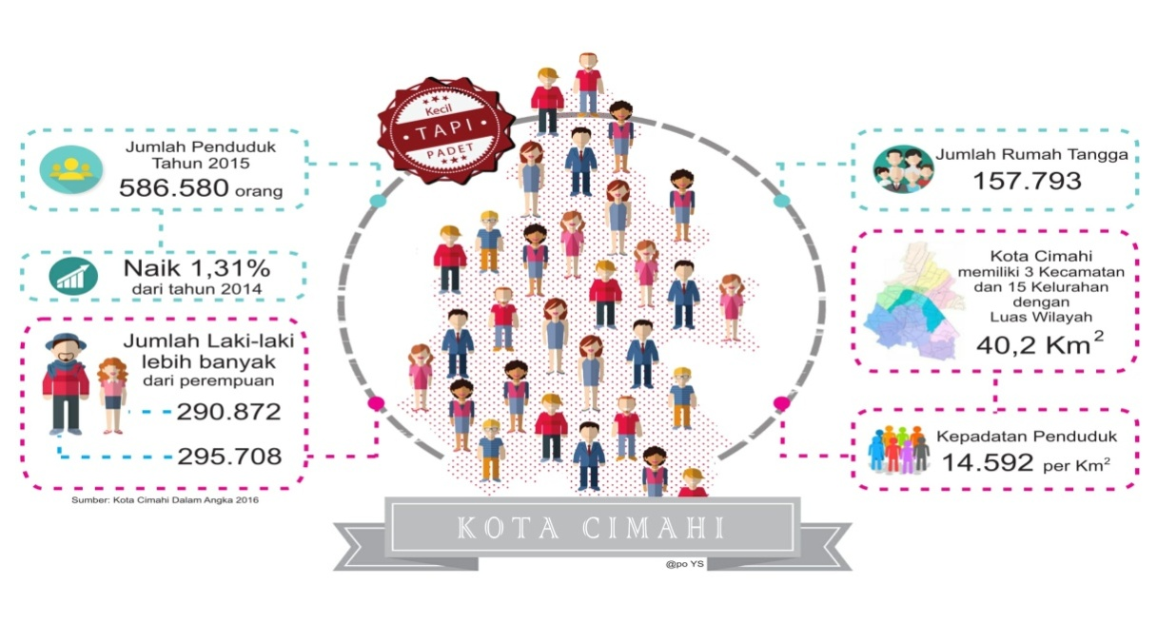

**Source : BPS Kota Cimahi, 2016**

The population of Cimahi City is quite high with the density of population centered at Cimahi city center that is in District Cimahi Tengah. With a high population causing Cimahi City also experienced problems experienced by major cities in Indonesia such as poverty and unemployment problems. The area with the population of Cimahi city has imbalances or imbalances so that the impact on the high number of poverty and high population density as well. The picture below will provide an overview of the poverty figure and poverty depth figures in Cimahi city, as follows:

**Figure 3.3**

**Poverty Rate in Cimahi City 2016**

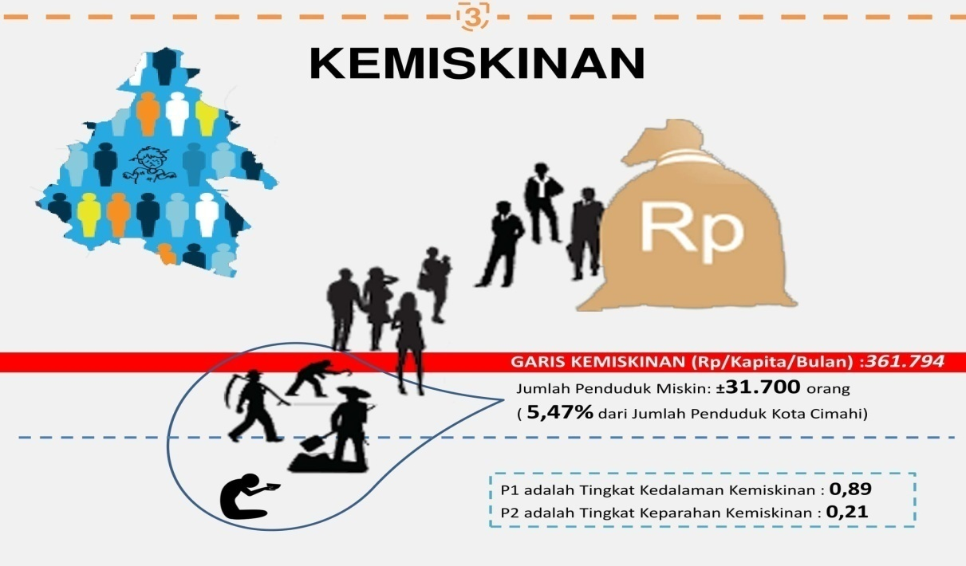

**Source: BPS Kota Cimahi, 2016**

The poverty rate in Cimahi City in 2016 was at 31,700 people or 5.47% of the total population of Cimahi City at 586,580 in 2015. This poverty rate indicates that Cimahi city ​​is also inseparable from the very complex social problem of poverty with an area that is categorized as densely populated. Various efforts were made by Cimahi city government to reduce poverty rate. One of them is the implementation of programs initiated by the central government through the Ministry of Social Affairs of the Republic of Indonesia is the Joint Business Group Program, Family Hope Program and e-Warong KUBE PKH Program that has been launched since 2006.

The amount of data of KUBE beneficiaries in Cimahi City is 250 residents, spread in North Cimahi Subdistrict, Cimahi Tengah and South Cimahi Subdistrict. Data relating to the number of KUBE participants are described as follows:

**Table 3.2**

**List of KUBE Ministry of Social Assistance in Cimahi City, FY 2014**

**Ministry of Social Assistance in Cimahi City FY 2014**

|  |  |  |  |
| --- | --- | --- | --- |
| **No.** | **Nama Kelompok** | **Alamat** | **Jenis usaha** |
| 1 | Taruna Karya | RT 03 RW 04 Kel. Melong | Konveksi |
| 2 | Sawargi | RT 02 RW 07 Kel. Melong | Olahan Pangan |
| 3 | Mohicand Mind | RT 02 RW 14 Kel. Melong | Asesoris |
| 4 | Nusa Indah | RT 04 RW 17 Kel. Melong | Catering/Olahan Pangan |
| 5 | Sawargi 21 | RT 03 RW 21 Kel. Cibeureum | Konveksi |
| 6 | Karangsari | RT 03 RW 03 Kel. Cibeureum | Bakpia |
| 7 | Rancabentang | RT 04 RW 14 Kel. Cibeureum | Konveksi |
| 8 | Harapan Maju | RT 02 RW 01 Kel. Cibeureum | Es Goreng |
| 9 | Raos Mandiri | RT 02 RW 15 Kel. Cipageran | Catering |
| 10 | Saluyu Mandiri 07 | RT 02 RW 07 Kel. Cipageran | Olah Pangan Keripik  Pisang |
| 11 | Cimekar Mandiri | T 01 RW 29 Kel. Cipageran | Warungan |
| 12 | Sawah Lega Mandiri | RT 02 RW 02 Kel. Cipageran | Warungan |
| 13 | Tulip Mandiri | RT 02 RW 18 Kel. Citeureup | Warungan |
| 14 | Sedap Malam | RT 03 RW 03 Kel. Citeureup | Warungan |
| 15 | Saluyu Mandiri | RT 05 RW 10 Kel. Citeureup | Ternak Lele |
| 16 | Sawarfi Mandiri | RT 04 RW 09 Kel. Citeureup | Catering/Oleh Pangan |
| 17 | Pawon Sawargi | RT 01 RW 11 Kel. Baros | Catering |
| 18 | Motekar | RT 03 RW 06 Kel. Baros | Ternak Lele |
| 19 | Sawargi | RT 04 RW 06 Kel. Baros | Catering/Kue Basah |
| 20 | Sugema | RT 01 RW 11 Kel. Baros | Menjahit |
| 21 | Kenari | RT 03 RW 16 Kel. Baros | Ternak Burung |
| 22 | MGM | RT 08 RW 01 Kel. Cimahi | Olahan Bakso |
| 23 | Animas | RT 02 RW 07 Kel. Cimahi | Abon Ikan Mas |
| 24 | Pista | RT 07 RW 01 Kel. Cimahi | Ternak Burung |
| 25 | Tunas Mekar | RT 04 RW 02 Kel. Cimahi | Warungan/Olah Pangan |

**Source: Dinas Sosial Propinsi Jawa Barat, 2016**

Based on the table number of KUBE in Cimahi City according to table 3.2 that the number of e-Warong KUBE currently exist in Cimahi City is 21 e-Warong KUBE. E-Warong KUBE is also included in KUBE Services under the auspices of the Ministry of Social Affairs of the Republic of Indonesia. E-Warong KUBE is a non-cash food aid agency (BPNT) for KPM Program Keluarga Harapan.

The implementer of e-Warong KUBE consists of 10 members who are KPM Program Keluarga Harapan, then to facilitate the process of distributing non- cash food aid , in accordance with the guidelines of the implementation of non-cash food assistance (BPNT), each e-warong KUBE accompanied by a supervisor e-warong KUBE. Here is the name of supervisor for all e-warong KUBE in Cimahi City:

**Table 3.3**

**List of Supervisors e-Warong KUBE in Cimahi City Year 2018**

|  |  |  |  |  |  |
| --- | --- | --- | --- | --- | --- |
| **No.** | **Penyelia** | **Pendamping KUBE** | **Nama e-Warong KUBE** | **Kecamatan** | **Kelurahan** |
| 1. | Arum | Arum Y S | Harum Manis | Cimahi Selatan | Cibeber |
| 2. | Herni | Asep Sutarli | Mentari Asri | Cimahi Selatan | Cibeureum |
| 3. | Dicky | Asep Sutarli | Mekar Berseri | Cimahi Selatan | Leuwigajah |
| 4. | Putut | Arum Y S | Melong Bersemi | Cimahi Selatan | Melong |
| 5. | Nina | Arum Y S | Mulya Gembira | Cimahi Selatan | Melong |
| 6. | Ali | Asep Sutarli | Aselya Ceria | Cimahi Selatan | Utama |
| 7. | Yoshinta | Liya Marliani | Harapan Mulya | Cimahi Tengah | Baros |
| 8. | Joko P | Sinta H | Sedap Sari Jaya | Cimahi Tengah | Cigugur Tengah |
| 9. | Uun S | Sinta H | Sukamaju Mandiri | Cimahi Tengah | Cigugur Tengah |
| 10. | Sri Rusyani | Sri Rusyani E | Sweety | Cimahi Tengah | Cigugur Tengah |
| 11. | Oki Aji | Sri Rusyani E | My Love | Cimahi Tengah | Cimahi |
| 12. | Sri Rusyani | Sri Rusyani E | Pujaan Hati | Cimahi Tengah | Karangmekar |
| 13. | Liya | Liya Marliani | Merah Dahlia | Cimahi Tengah | Padasuka |
| 14. | Sinta | Sinta H | Amanah | Cimahi Tengah | Aetiamanah |
| 15. | Kriswanti | Kriswanti | Citra Jati 1 | Cimahi Utara | Cibabat |
| 16. | Sriadi Bageswara | Kriswanti | Citra Jati 2 | Cimahi Utara | Cibabat |
| 17. | Bobby | Ummu Hani R | Citra Mandiri | Cimahi Utara | Cipageran |
| 18. | Eris | Ummu Hani R | Saluyu Ngawangun | Cimahi Utara | Cipageran |
| 19. | Aliyah | Ummu Hani R | Citra Saluyu | Cimahi Utara | Citeureup |
| 20. | Ummu Hani | Ummu Hani R | Mantap | Cimahi Utara | Citeureup |
| 21. | Dewi | Kriswanti | Jati Mandiri | Cimahi Utara | Pasirkaliki |
| 22. | Sawiji | Liya Marliani | Citra Cipageran | Cimahi Utara | Cipageran |
| 23. | Revi | Asep Sutarli | Wonderfull Land | Cimahi Selatan | Cibeureum |

**Source: Data Sekretariat PKH Kota Cimahi, 2018**

**4.2** **Economic Empowerment Conditions e-Warong KUBE in Cimahi City**

Based on the results of participant observation, in-depth interviews and also the literature study that researchers conducted in two e-warong KUBE e-warong KUBE My Love and e-warong KUBE Citra Saluyu, researchers can describe the comparison of these two e-warong from various aspects. This comparison is not to show the best e-warong, only this comparison aims to provide an overview of how the preparation, implementation, evaluation and empowerment is done in both e-warong KUBE. Here is a comparison picture of e-warong KUBE My Love and e-warong KUBE Citra Saluyu namely:

**Table 4.1**

**Comparison Overview of e-warong KUBE My Love and e-warong KUBE**

**Citra Saluyu**

|  |  |  |  |
| --- | --- | --- | --- |
| **No.** | **Aspects of Difference** | **e-Warong KUBE My Love** | **e-Warong KUBE Citra Saluyu** |
| 1. | The process of Establishing a member of e-warong KUBE | Formed voluntarily through selection by supervisors along with RT head, and most of the e-warong KUBE members do not work. | Formed voluntarily and selected by e-warong supervisors and PKH assistants and most members already have jobs outside of e-warong KUBE. |
| 2. | Current channeled BPNT types | ⮚Rice  ⮚Egg  ⮚Beef  ⮚Sugar  ⮚Cooking oil  ⮚Wheat flour | ⮚Rice  ⮚Egg  ⮚Wheat flour  ⮚Cooking oil |
| 3. | Schedule of Distribution of BPNT | Distribution every 1 month | Distribution every 2-3 months |
| 4. | Business Development | *Progress* formation of cooperatives already exist | Still focus on the distribution of BPNT |
| 5. | Bookkeeping | Already and complete include:  ⮚Have ART  ⮚Monthly Bookkeeping  ⮚Bookkeeping member's savings  ⮚Member attendance  ⮚List of KPM PKH | It is still simple, covering only the monthly bookkeeping related to the distribution of BPNT and the PKM KPM name list. |
| 6. | Stewardship and Membership | The board consists of 10 people, which consists of chairman, secretary, treasurer and member. The selection of stewardship is directly elected by members of the e-warong KUBE. | The e-warong management consists of 4 people, consisting of chairman, secretary, treasurer and member. Changed the management every 2 months through a joint meeting. |
| 7. | Share / Profit Sharing | Referring to the ART that has been made are:  ⮚20% for additional capital  ⮚10% for promotion  ⮚20% for social funds  ⮚50% for honorarium of supervisor and e-warong actor (division of honor for e-warong participant in accordance with activity and attendance). | The distribution of results is equally distributed to each supervisor and e-warong KUBE actor, no percentage of revenue sharing in the form of ART. |
| 8. | Number of KPM PKH | 125 Family Beneficiaries of PKH. | 300 Family Beneficiaries of PKH. |
| 9. | Planning and Evaluation | Disbursement planning is done through weekly meetings with the formation of RKTL (Activity Plan and Follow Up) and evaluation conducted by supervisor and e-warong KUBE. | Planning is done through meetings before the BPNT distribution activities are carried out, the evaluation is done by the supervisor and the KUBE e-warong perpetrator. |
| 10. | Mentoring and Supervision | Performed by supervisors, PKH assistants and supervisors from the local kelurahan. PKH assistants regularly conduct meetings every month to conduct supervision related to bookkeeping, RKTL and reporting. | Performed by supervisors, companions and supervisors from the kelurahan. Unscheduled meetings only as per BPNT distribution needs only. |

**Source: Study of literature, 2018**

**4.** **3** ***Road Map of*** **Economic Empowerment through** ***Income Generating*** **KUBE e-Warong Actors in Cimahi City**

This Road Map will provide a general overview of the current empowerment condition that has been implemented by e-Warong KUBE that has been running for 17 months since it was inaugurated on June 27, 2016 ago. *The road* *map* below is illustrated according to the results of in-depth interviews, partisan observation and literature studies conducted by researchers.

**Figure 4.7**

**Economic Empowerment through** ***Income Generating***

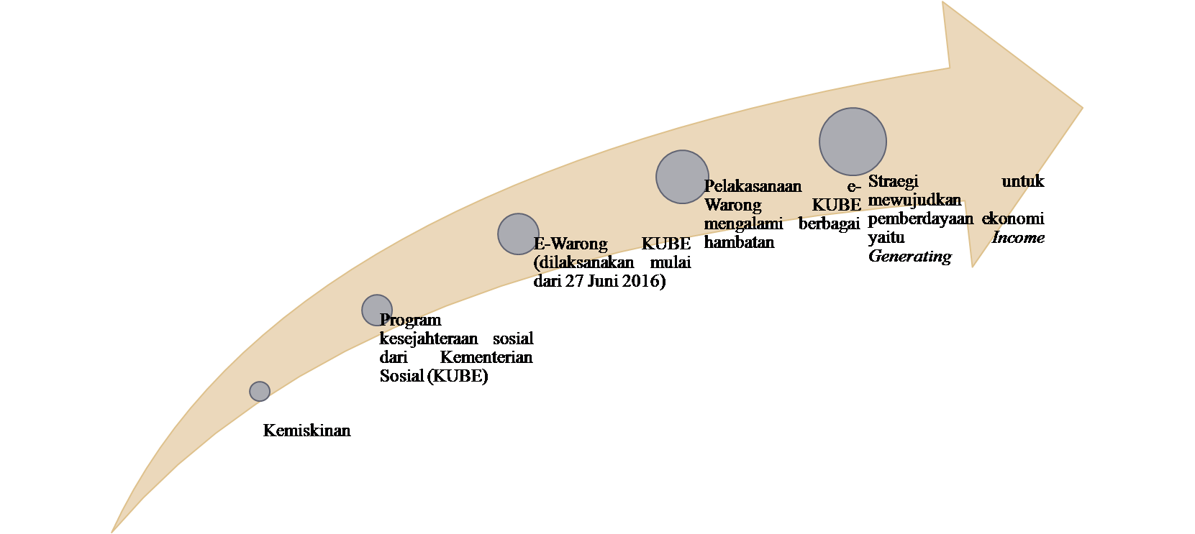

**Source : Studi Literatur, 2017**

The condition of e-Warong KUBE can be described not yet running optimally, this is caused by preparation and planning that is not ready and mature. The implementation of the Joint Business Group (KUBE) is not yet optimal, but it has already progressed to the e-Waro ng KUBE stage so that KUBE actors are not ready to implement or switch to e-Warong KUBE.

The current condition of e-Warong KUBE is still vacuum and often closes, many influencing factors such as the increasingly unproductive group members, who choose to focus on their work outside the e-Warong KUBE group, the distribution of food aid from Bulog whose schedule not deceiving sometimes 2-3 months of new aid distribution, e-Warong KUBE has not been well established related to the understanding in the operation of various non-cash transactions, e-Warong KUBE income is still not stable due to the many complaints from beneficiary families (KPM) complaining that the quality of rice and eggs converted through e-Warong KUBE is less or can be categorized ugly for example rice smells musty and eggs that are not in accordance with the existing standards in the market.

The readiness of the e-Warong KUBE's companion and social welfare personnel is also not optimal. This is related to how the productive economic enterprises developed in e-Warong KUBE today. Variations of business developed are still within the scope of processed foods alone, in addition to the rolling of capital in e-Warong KUBE also runs slowly, it is seen with the unstable e-Warong KUBE income and e-Warong KUBE players also have difficulty in saving and accessing capital with the parent institutions such as cooperatives or banks because there is no special training related to how to access capital or access to financial institutions.

Thee-Warong KUBE *Road Map* in Cimahi City is still in the e-Warong KUBE stage, the empowerment strategy through *income generating* has not been implemented maximally in e-Warong KUBE at this time. P e enhancing the income, fixed income, scrolling funds or capital and access to capital institutions still have not been implemented optimally in the e-Warong KUBE today.

Readiness of KUBE e-warong players, technical implementation readiness, inadequate number of e-Warong KUBE members and lack of understanding of what tasks and functions of e-warong KUBE are the obstacles that perceived by e-Warong KUBE and supervisors. So that can be described the condition of economic empowerment through *income generating* perpetrators e-warong KUBE in Cimahi City at this time has not materialized.

**4.4 Analysis of SWOT e-Warong KUBE in Cimahi City**

To complete the description of the current condition of economic empowerment through *income generation* of KUBE e-warong in Kota Cimahi, the researcher mapping or analyzing the potentials and problems that exist in the implementation of e-warong KUBE in Cimahi City. The mapping of the problems and potentials that exist in the implementation of e-warong KUBE in Cimahi City researchers presented in the form of SWOT analysis. SWOT analysis of the researcher is described in the table below:

**Table 4.2**

**Results of SWOT e-Warong KUBE Analysis in Cimahi City**

|  |  |
| --- | --- |
| **Strength** | **Weakness** |
| 1. Already there is a fixed target or target of the KPM Program Keluarga Harapan. 2. Capital facilities and business premises already provided by the government. 3. The presence of mentoring from a sustainable e-warong KUBE supervisor. 4. The program is sustainable and there is a clear legal basis. 5. All members of the group have the authority to continue developing their business in e-warong KUBE. 6. Cooperation built into groups. 7. Business variation can be expanded widely. | 1. The formation of the e-warong KUBE group is still lack of careful planning. 2. Socialization of the program is still lacking, so that many of e-warong KUBE do not understand the implementation procedure. 3. The readiness of the system related to the distribution, reporting and supervision procedures is still lacking. 4. Most KUBE e-warong actors are already working, so do not focus as e-warong KUBE. 5. Understanding of KUBE e-warong entrepreneurs for entrepreneurship is still lacking. 6. E-warong KUBE is less empowered, so e-warong KUBE only opens when channeling BPNT. 7. Networks or partnerships are still not well developed with business actors or access to financial institutions. 8. Delivery schedule from the center is still not regular. |
| **Opportunity** | **Threat** |
| 1. Increased income of e-warong KUBE players. 2. Opportunity to develop business. 3. Establishment of a network of actors of e-warong KUBE, agents and KPM Program Keluarga Harapan. 4. Facilitate access to financial institutions. 5. Building cooperation and creativity. 6. Each member has the opportunity to have savings. | 1. The lack of socialization about the program has an impact on the misunderstanding of the people around e-warong KUBE, which considers e-warong KUBE as a business competitor. 2. The group dynamics are still lacking, so many members of e-warong KUBE are resigning. 3. Less equity among members, so e-warong KUBE is only controlled by some people only. 4. The slow innovation of business, so that the scavenging of threatened funds is not implemented. 5. There are no antiretroviral / antiretroviral agents in the group, resulting in jealousy of the division of group earnings. |

**Source: Research Results, 2018**

**4.5** **Factors affecting Economic Empowerment through *Income Generating* actors e-Warong KUBE in Cimahi City**

e-Warong KUBE is a form of program launched by the Ministry of Social Affairs of the Republic of Indonesia, implemented by beneficiary families of PKH (Family Hope Program). Implementation of food aid distribution through e-warong KUBE implemented by e-warong board consisting of 10 people board. Smooth and successful implementation of e-warong KUBE of course very influenced by various factors. Researchers will describe the internal factors and external factors that affect economic empowerment through *income generating* KUBE e-warong players in Cimahi City as follows:

* + 1. **Internal Factors**
  1. Group Dynamics, group dynamics under construction by KUBE e-warong actors is still very low, it is apparent that there is still a lack of information exchange related to the type of business and business development that will be run.
  2. The spirit of Entrepreneurship, a member of e-warong KUBE currently mostly comes from KPM who do not yet have business, so their ability to see business opportunity still need to get guidance from KUBE e-warong supervisor.
  3. Management, KUBE e-warong actors have been able to perform management in the form of simple start of bookkeeping, make ART and plan activities to be doing.
  4. Social Interaction, a meeting that is only done every month before the distribution of BPNT becomes a factor inhibiting the establishment of effective social interaction in e-warong KUBE.
     1. **External Factors**
  5. Assistance and Development, KUBE e-warong supervisor and PKH assistant have a very important role in the implementation of e-warong KUBE. Continuous mentoring and coaching will provide stimulus or stimulus to e-warong KUBE to continue to grow.
  6. Monitoring and Evaluation, monitoring and evaluation are conducted in stages between *stakeholders* in the implementation of e-warong KUBE. Monitoring conducted starting from the chairman of e-warong KUBE, supervisor, PKH companion, supervisor from keluraha samapai social office Cimahi City.

**4.6 Efforts made to realize economic empowerment through *income generating* actors e-Warong KUBE in Cimahi City**

The indicator of the realization of the *Income Generating* (KUBE) in April 2015 states that: "Indicators of the realization of *Income Generating* are an increase in family economic income, income generation, business capital and the ability to access institutions finance as sustainable business needs ".

**4.6.1 The realization of fixed income e-Warong KUBE perpetrators**

Efforts to realize *income generating* is one of the existence of income or fixed income e-warong KUBE in Cimahi City is not only the responsibility of e-warong supervisor KUBE. However, many parties are involved in the realization of the fixed guarantees of the KUBE Jasa Coordinator from Dinsos Kota Cimahi, PKH Coordinator Coordinator, PKH Assistant of each sub-district, KUBE e-warong Supervisor, Supervisor from Kelurahan and no less important is the participation and efforts made by the perpetrators e-warong KUBE itself. The willingness and hard work of the KUBE e-warong actors is very important to the realization of a steady income.

**4.6.2 Increased income of e-warong KUBE perpetrators**

Increasing the earnings of each e-warong KUBE in Cimahi City vary, based on interviews and observations that researchers do on e-warong KUBE Citra Saluyu and e-warong KUBE My Love is described that members of e-warong KUBE Citra Saluyu mostly already have jobs , so its members are more prioritize their current work, so e-warong KUBE as a side job so that business development, financial management and innovation in e-warong KUBE can not be seen clearly.

The description of the income increase is felt differently by the KUBE My Love e-warong actors, the increase in income and the influence of the existence of e-warong KUBE is felt by its members. This is stated by members of e-warong KUBE My Love which states that its members not only have increased revenue, but also every member now has savings that they can manage in e-warong KUBE. Good financial management and the existence of a clear ART in e-warong KUBE My Love has a good enough influence to suppress every member of e-warong KUBE to continue to develop variations of existing businesses, other than that e-warong KUBE My Love is also mostly not work so they can focus on managing e-warong KUBE.

**4.6.3 Provision of Business Capital to KUBE e-warong Actors**

Achieve economic empowerment through *income generating in* addition to providing a steady income and income increase, efforts made by the government, especially the Ministry of Social Affairs of the Republic of Indonesia in realizing the economic empowerment of e-warong KUBE adalam through the provision of venture capital.

The business capital given to the KUBE e-awarong actor is Rp. 20.000.000, used for the renovation and manufacture of e-warong KUBE Rp.10.000.000, and used to buy equipment e-warong KUBE include scales, shelves, *vacuum siller* and other equipment of Rp. 10,000,000.

**4.6.4 Access to Financial Institutions Perpetrators of e-warong KUBE**

Adjustment, coordination, system readiness and data validation and good reporting are still the focus of the implementation of e-warong KUBE in Kota Cimahi today. So to provide further training on access to capital or access to financial institutions still can not be implemented optimally in e-warong KUBE today. Based on interviews and observation of the participants who do penliti in two e-warong KUBE still encountered an *error* combo card or called the balance "zero".

KUBE e-war *error* card problem that exist in Cimahi City, this is caused by validation of data sala from the center, so many KPM Family Hope Program that every month does not get balance with nominal Rp. 120.000, so when the validation of the balance through the friction machine yabg in e-warong KUBE zero balance, this causes KPM Program Keluarga Harapan can not obtain BPNT in e-warong KUBE.

**4.7 Practical Implications of Social Works in Achieving Economic Empowerment of KUBE E-Warong Actors in Cimahi City**

Social work practice is carried out in various aspects of social services involved in social welfare efforts. Social work practices in providing social services is in providing empowerment, coaching and guidance to clients either in the sphere of peroranggan or in the institutional scope. One of the social work practices in the institutional scope of Industrial Social Work.

**4.7.1 The Role of Complementary PKH as Reinforcement ( *Empowering* )**

Empowering or *Empowering* is a very important role to be undertaken by PKH supporters in KUBE e-warong activities, because the basic concept or foundation of e-warong KUBE is to create empowerment for e-warong KUBE one of them is economic empowerment. According to Ife (1995) in Suharto (1997: 210-224) states that strengthening or *empowering* is "an attempt to boost the power of the weak or disadvantaged".

The role of PKH companion in giving power to the weak people is the KUBE e-warong perpetrator is given the opportunity to form his own group consisting of RTSM (Household Very Poor) and then collected into one to form e-warong KUBE.

**4.7.2 The Role of Complementary PKH as Enabling ( *Enabling* )**

The role of PKH assistants in assisting and facilitating the access of KUBE e-warong operators in Kota Cimahi in terms of accessing financial resources, looking at business opportunities, identifying potentials within the KUBE e-warong group that can be developed to grow the economy of KUBE e-warong actors, the PKH facilitator is able to realize the economic empowerment of KUBE e-warong perpetrators through continuous information, guidance, supervision and guidance provided by PKH assistants to be able to jointly overcome the economic difficulties experienced by e-warong KUBE actors, by utilizing the potential possessed by perpetrator of e-warong KUBE.

**4.7.3 The Role of Complementary PKH as Protector ( *Protecting* )**

PKH companion role as protector ( *protecting* ) the industry practice of social work carried out in the e-Warong KUBE activities include providing protection to the rights of the offender e-Warong KUBE. Perpetrators of e-warong KUBE are those who belong to the poor or less fortunate. Then the rights of the brand as KPM PKH that must be protected and championed by PKH companion.

In accordance with the general guidelines of the implementation of the Family Hope Program (2016: 31) on the rights of participants or KPM Program Keluarga Harapan namely:

a. Obtain cash assistance whose amount is adjusted accordingly

provisions of the program.

b . Getting service in health and education facilities for all

family members .

c. Registered and get complementarity programs and

synergy of other poverty alleviation.

**4.7.4 The Role of Complementary PKH as Supporter ( *Supporting* )**

Providing support in the form of seminars , motivation, guidance, information and coaching and training related to social entrepreneurship is a form of PKH's companion role as an industrial social worker. Simultaneous support provided by the companion will greatly influence the KUBE e-warong entrepreneurs in establishing their business. The more businesses and capital managed by the KUBE e-warong operators will be increased, access to open financial institutions, and the realization of stable or stable *income* as an indicator of the realization of *income generating* KUBE e-warong perpetrators in Cimahi City.

**CHAPTER V**

**CONCLUSIONS AND RECOMMENDATIONS**

* 1. **Conclusions**

1. Economic empowerment through *income generation* of KUBE e-warong operators in Kota Cimahi still has not been realized optimally. This can be illustrated in several categories: the *first* UEP training that has not yet materialized can be seen from the business variation and the type of business developed by e-warong KUBE is still limited in the distribution of BPNT only. *Both* access to financial institutions have not materialized, the financial source of e-warong KUBE is still sourced from the capital assistance provided by the government. *The third* implementation of continuous coaching has been carried out but the PKH facilitator is still limited so that one of PKH's supporters oversees 3 e-warong KUBE in Cimahi City.
2. Factors affecting economic empowerment through *income generating* actors e-warong KUBE in Cimahi City is divided into two factors namely internal factors that include the dynamics of e-warong group is still low because most of its members have been working outside e-warong KUBE. The entrepreneurial spirit is still low because since the implementation of e-warong KUBE has never been given training on entrepreneurship. Group management management is still limited to some group members. Social interaction is still not optimal because the group meeting schedules are only one month-three months once in every channeling of BPNT. External factors include mentoring, guidance, monitoring and evaluation conducted by PKH assistants, supervisors and village authorities are running well enough.
3. Efforts implemented to realize economic empowerment through *income generating* actors e-warong KUBE include the provision of venture capital in cash with the amount of Rp. 20,000,000. Efforts to increase the income of KUBE e-warong entrepreneurs have been pursued through the procurement of member savings in some e-warong KUBE. Realizing fixed income is still not realized due to the aid for PKM PKH irregular, then the business variations are still limited to the distribution of BPNT. Access to financial institutions has not been realized in the implementation of e-warong KUBE, information and training related to access to financial institutions or capital has never been given to the KUBE e-warong perpetrators.
4. The practical implications of social workers in realizing economic empowerment through *income generation* of KUBE e-warong operators in Kota Cimahi have a role that includes the role of PKH assistants and as TKSK. PKH companion role as enabling ( *enabling)* identify potential and needs The e-Warong KUBE through ongoing mentoring and coaching. The role of *empowering* involves empowering any member to manage and manage the business and the preparation of ART in e-warong KUBE. Role as a protector ( *protecting* ) that plays a role to ensure rights every member of e-warong KUBE fulfilled includes the provision of venture capital, information as well as continuous coaching and mentoring. The role of the last PKH companion is as *supporting* which includes giving motivation, spirit and directing the KUBE e-warong to develop their business.

* 1. **Suggestions**

1. Social Service, planning and readiness of the system of e-warong KUBE implementation need to be reviewed and socialized again well, due to the facts in the field many e-warong KUBE players who do not understand about the implementation of e-warong KUBE system and the socialization about the program is still lacking so as to bring jealousy social environment in the existence of e-warong KUBE which assumes e-warong group KUBE as business competitor.
2. Assistant PKH and KUBE e-warong supervisors need to be given entrepreneurship-related training and management of capital management related to access to financial institutions for e-warong KUBE actors, because the development of e-warong KUBE business is still not developed only limited to the distribution of BPNT so e-warong KUBE often close and only open every 1-3 months at the time of disbursement of BPNT.
3. E-Warong KUBE's work partners are Bank BNI and Bulog, partners of e-warong KUBE actors, namely BNI Bank should participate actively in providing socialization and assistance for KUBE e-warong actors related to non-cash transaction process. Most of the KUBE and PKM PKH e-warong actors are still unaware and have not understood well how the process and the steps of doing non-cash transactions. For Bulog who became the partner of e-warong KUBE as the channel agent of BPNT is expected to improve and improve the quality of BPNT, because many complaints are submitted by the perpetrators of e-warong KUBE and PKM PKH who said that the quality of rice is not good even smelly and less feasible to be consumed .